UI test with selenium

1. 1-Types of Functional Tests
2. We will deploy the app service or VM after that we need to know the functionality how it works
3. In the CD pipeline only we include some test cases
4. Unlike earlier unit tests we have added in CI pipeline now we need to do in the CI pipeline
5. Functional test: your software implements each function we are NOT worried about the Implementation
6. The behaviour is supposed to be expected.
7. Behaviour is going to test. If you try to login any page with wrong credentials it will gives the error which is the behaviour test
8. In Non-Functional test character like performance and reliability is going to test
9. Example: If I put 1000 users in the site will 1000 users load will sustain or NOT like load testing
10. Smoke Testing: if my server is down or not or application is Up and running or not how do it test this we will send the request and gest the response basically we will send http request and we see the response if the status code is 200 it is success and if the status does not have 200 it is failure
11. We need to use curl command for initiating the HTTP request and we will get the respond to it and check the status code
12. Unit testing: perform most fundamental things like adding, subtracting etc., functions we will include however in real time scenario there might be complicated functions are there
13. Integration Testing: multiple software components work together like your application is made up of web application then it will have some database also and may be some middle tier also will be there or all of them working together and provides you an expected output. The application has to connect to database and then fill full the order
14. Regression testing: whenever will do some kind of change/existing behaviour changes or breaks or if you add a new feature then it will test software overall behaviour. Because if you made a code change in one place that may impact 100 places
15. Only through Regression testing we can say the change is consistent or not
16. Sanity testing: Involves testing of each piece of software and verify if the software is working and can undergo more thorough testing
17. Looks like a software tester will validate if you input some values whether it will work or NOT
18. User Interface testing: tests the behaviour of application user’s interface. It can be anything like facebook.com like you enter the credentials whether it is taking to the correct page or not
19. Through code we will dump the value into text box and ( and password) and through code will trigger the click ( Log In)

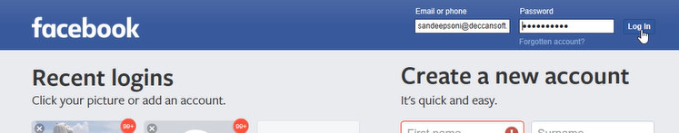

1. And the result we will capture and see what the behaviour of it is
2. If it as per the expectation we will take it and if it is NOT we will report it as error
3. If you want to do these manually it will weeks and times to do it if each application of the UI has to be tested
4. But if we take an extra effect in UI testing once we can have benefit of automating. It will verify the sequence or order of user interaction leads to expected result or not
5. We can test desktop applications like mouse, key board
6. We test our application most of the times in the favourite browser of the user or tester and rarely the test case will go through in all the browser which are available
7. It will test the input/output data in UI test it will test what is display to data is correct or NOT
8. It has to show correct animation of the page even it is resized or not
9. UI tests tools

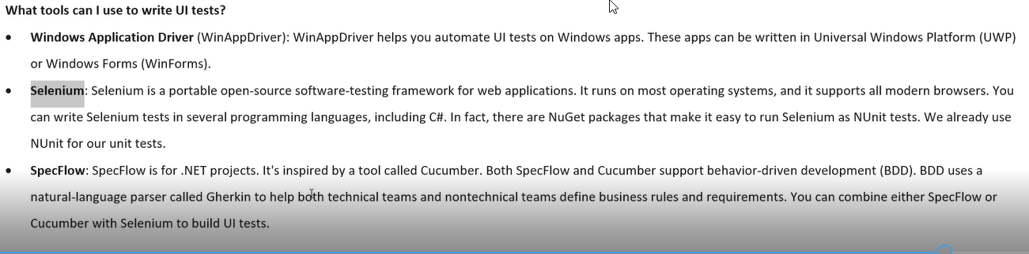

1. Windows application driver , windows based test application
2. selenium and SpecFlow:

2-Performing Selenium Testing on Dev Box

1. Selenium is the most important operating tool for testing windows-based application as well as web-based application
2. Majorly for web based application

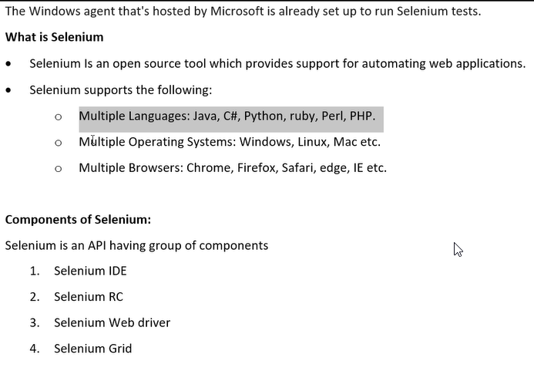

We will write code and through code we will set the value of text box or may be we will hit the button

Whenever html document is loaded into web browser it creates a DOM tree where all html tags most of the time it will become objects and the attributes of those tags become properties

How do UI testing in local system

Create a project by name web app and below are the steps how to do it

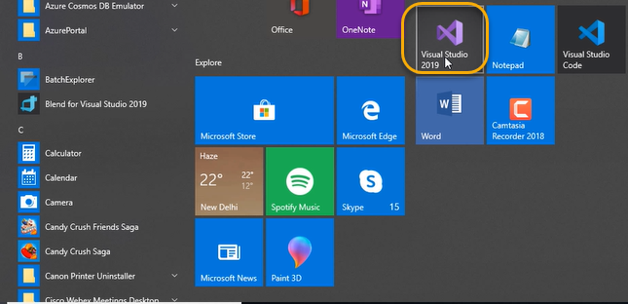

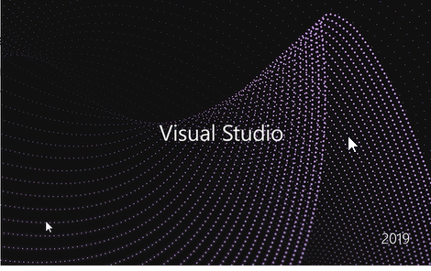

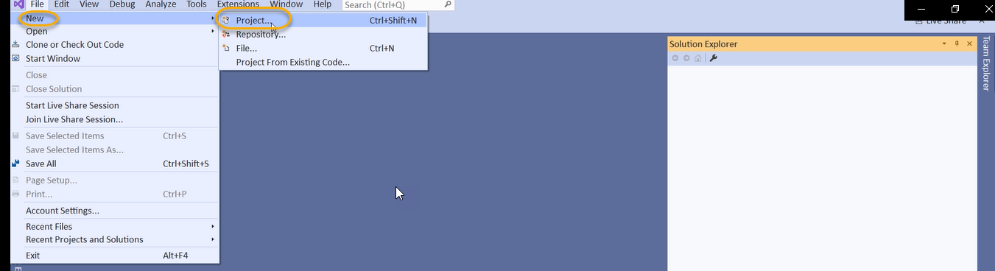

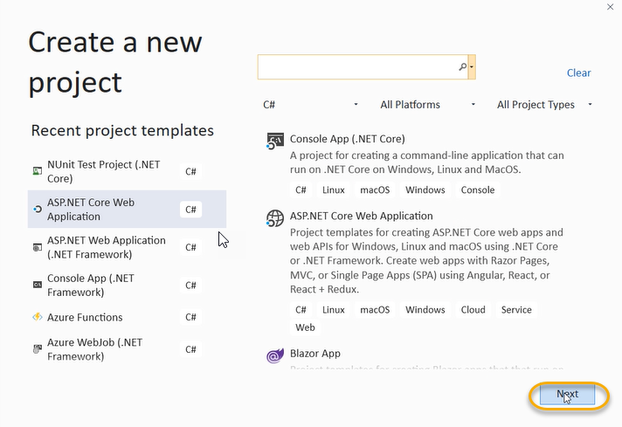

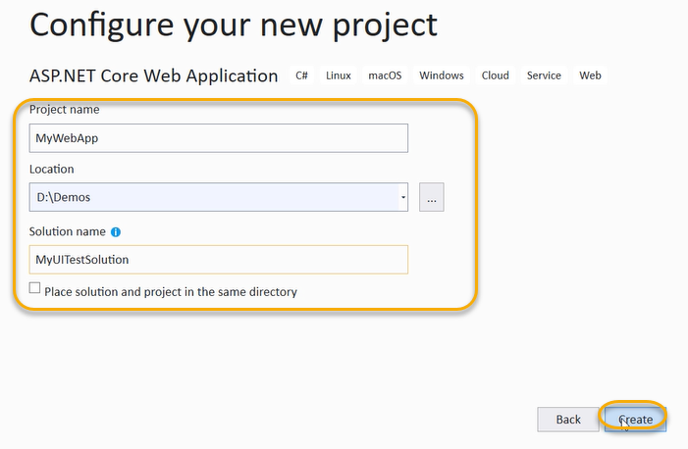

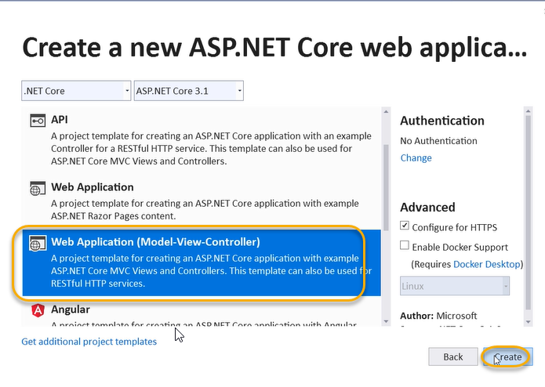

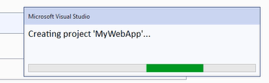

And in the existing solution only I would like to add one more project that would be like unit test project

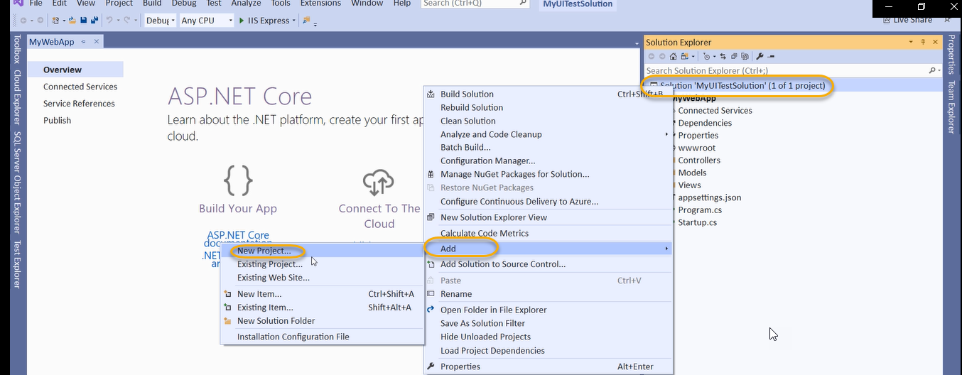

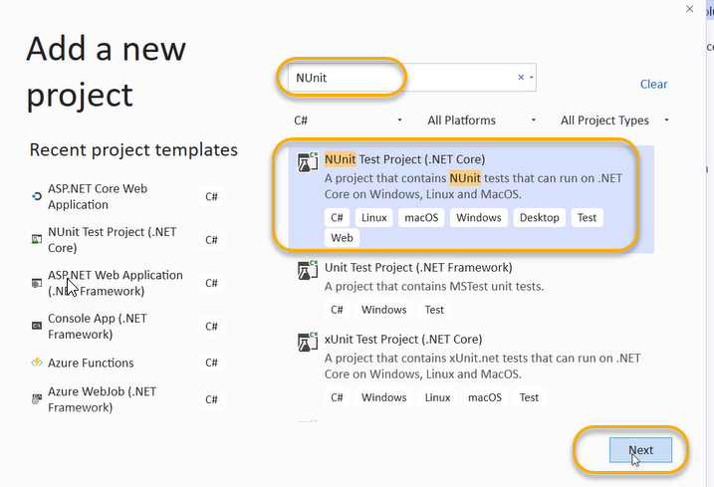

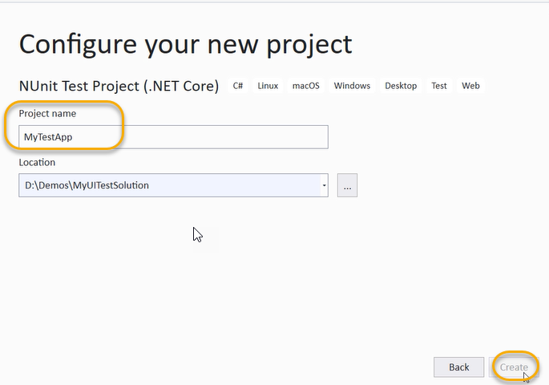

We are creating unit test project

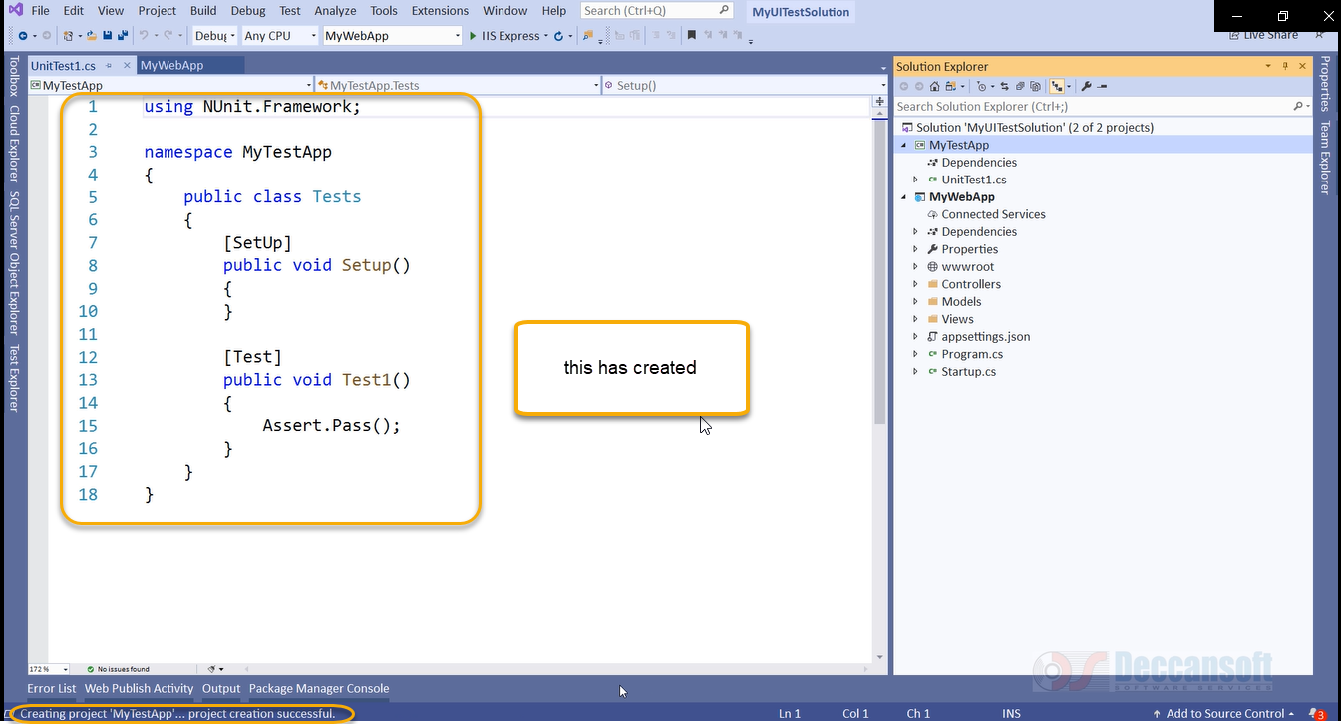

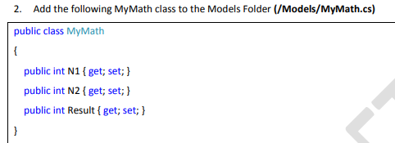

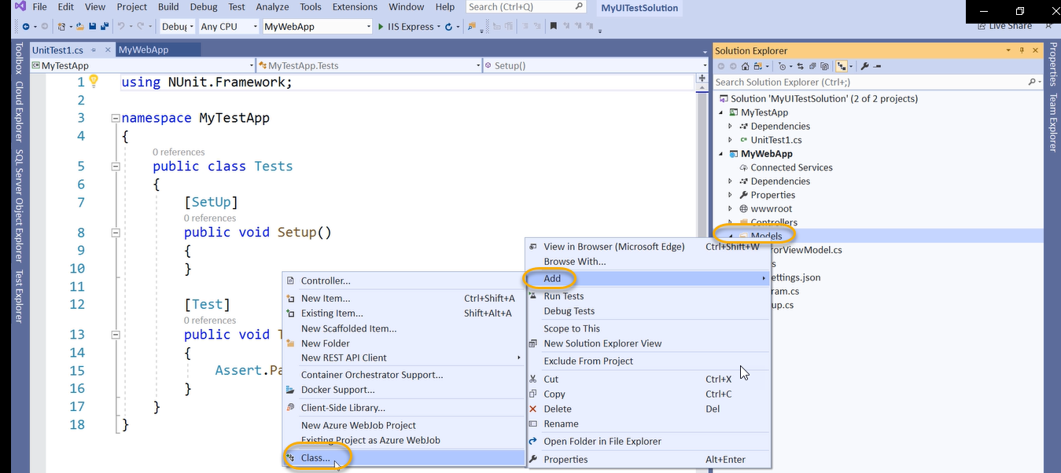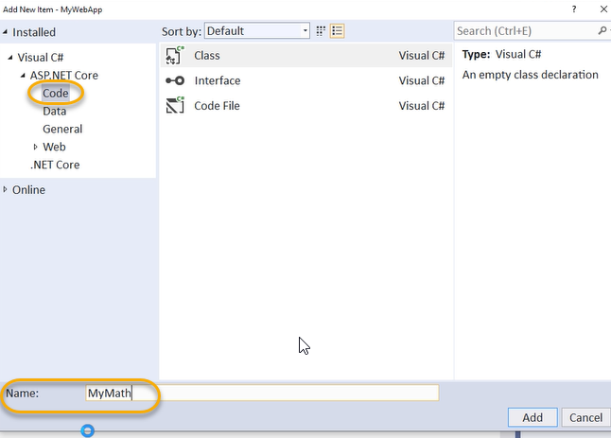

The class adding function is a developer Job

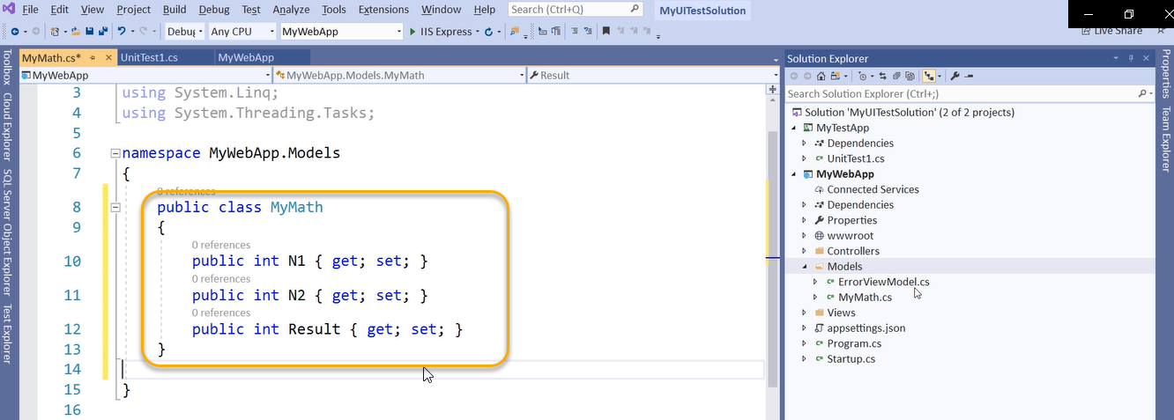

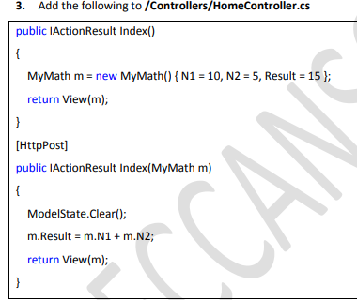

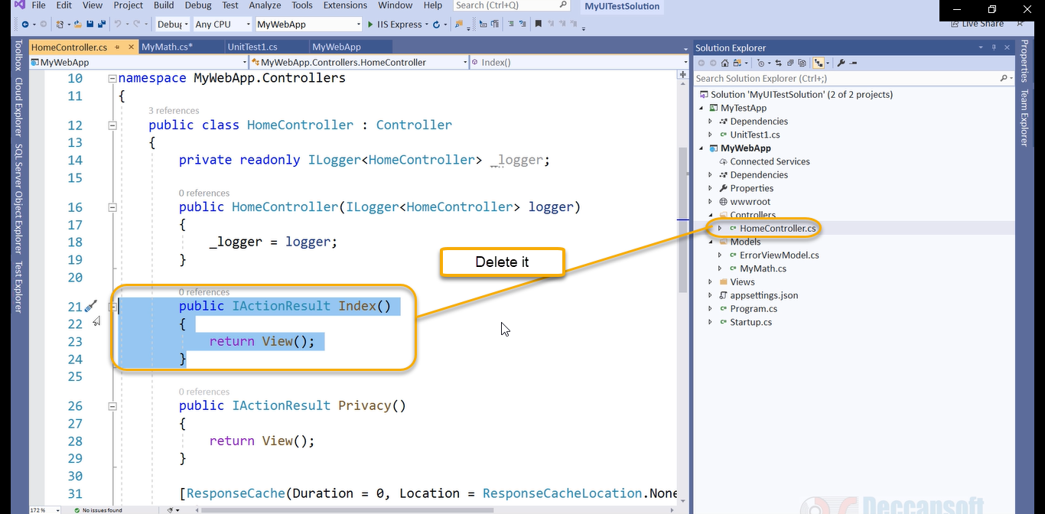

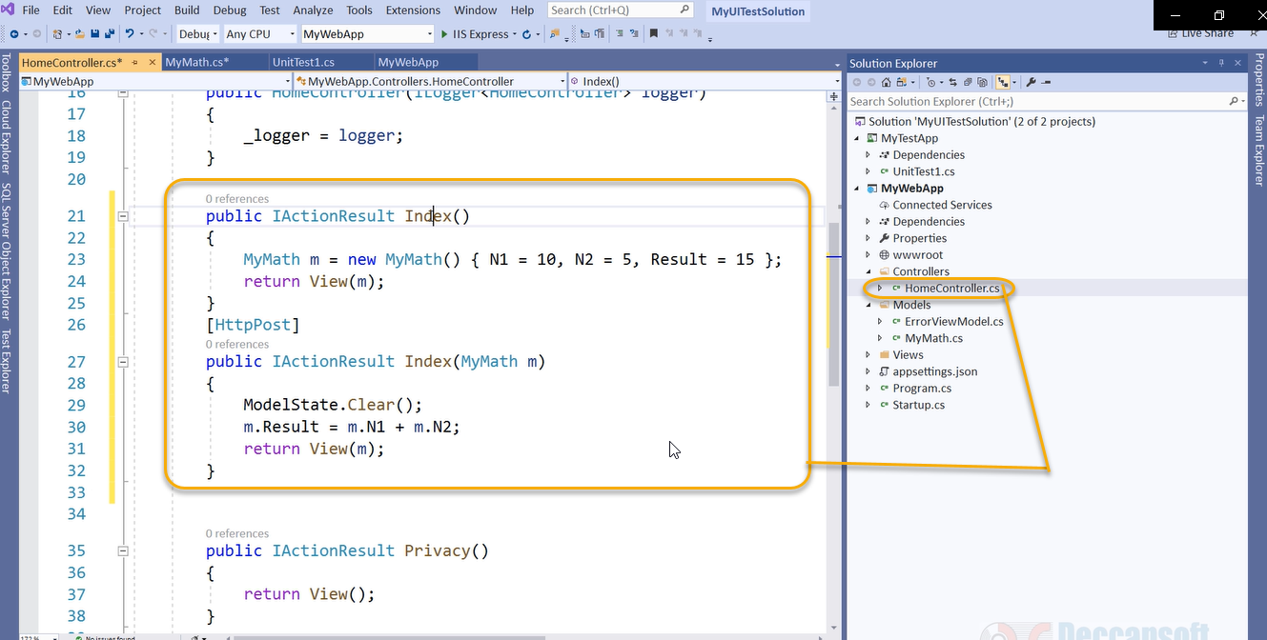

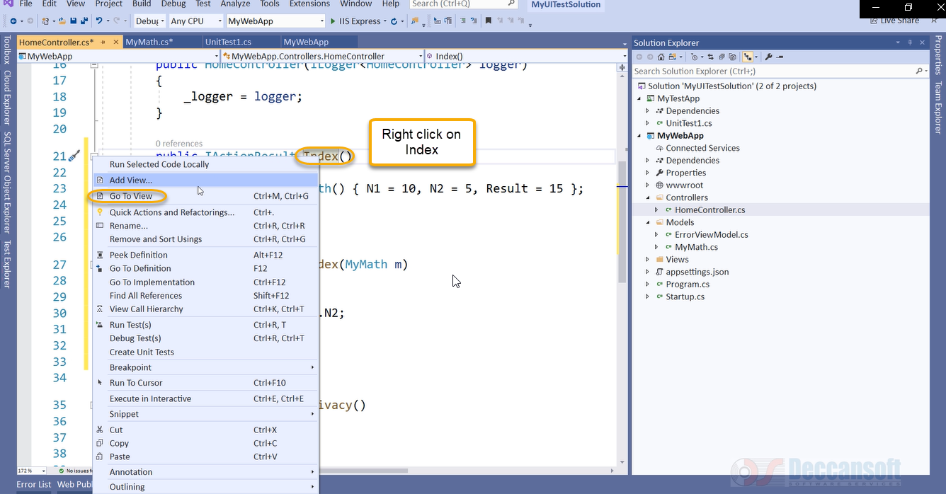

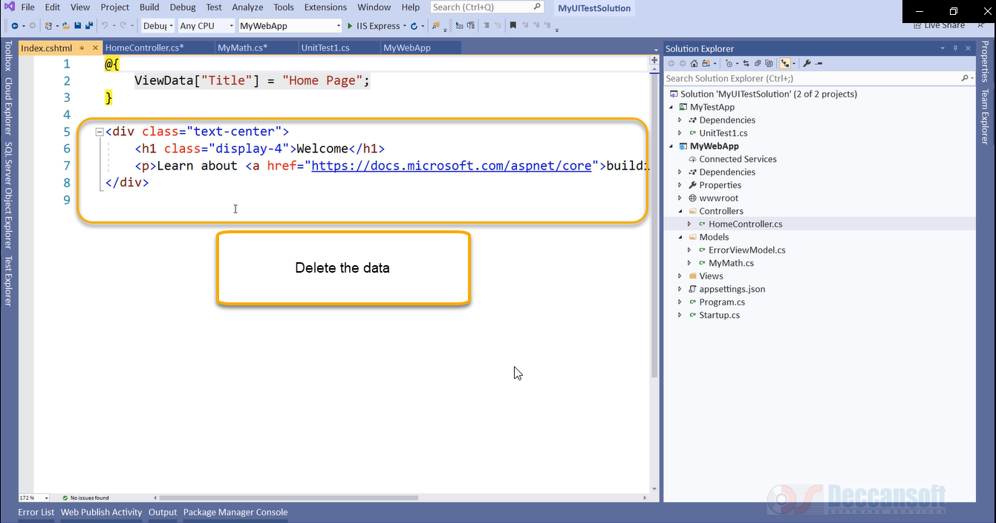

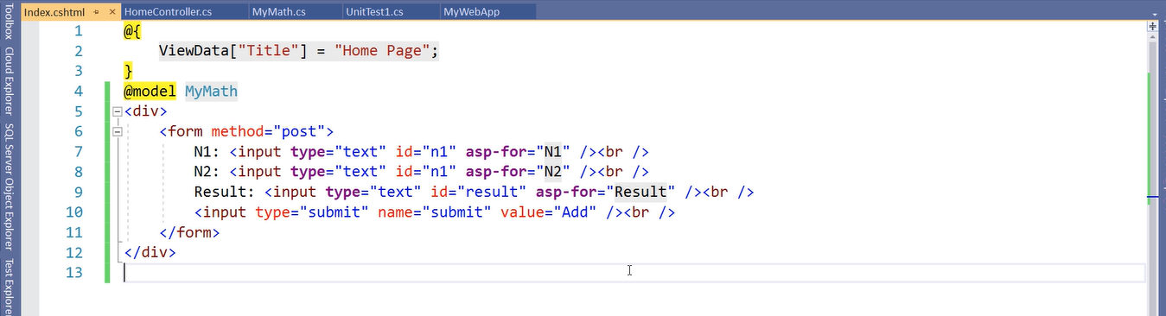

Run the build

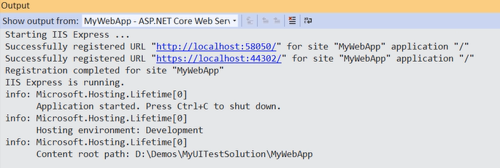

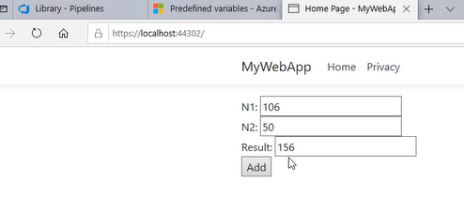

I don’t want to do this manually I want UI test to care of it

That means UI automation test should enter the value of N1, N2 and Click on Add and generates the result

Below are the steps

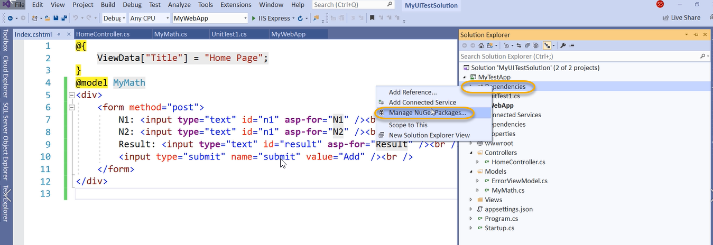

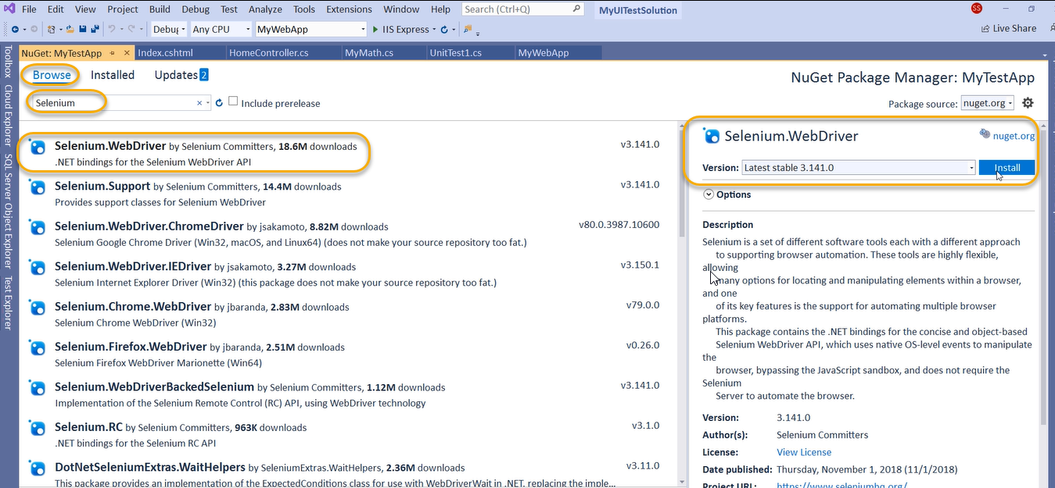

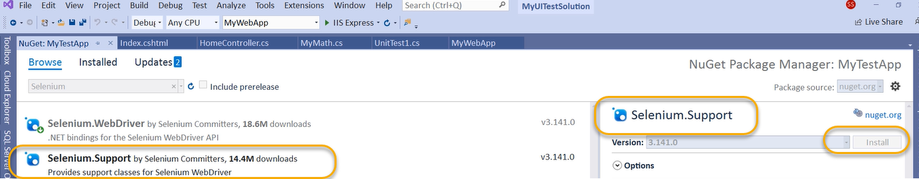

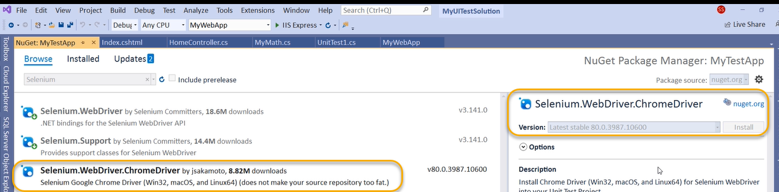

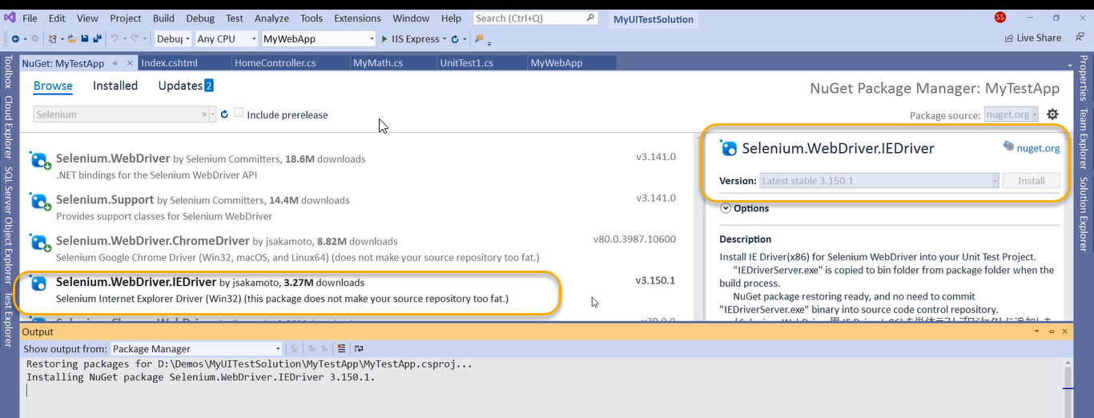

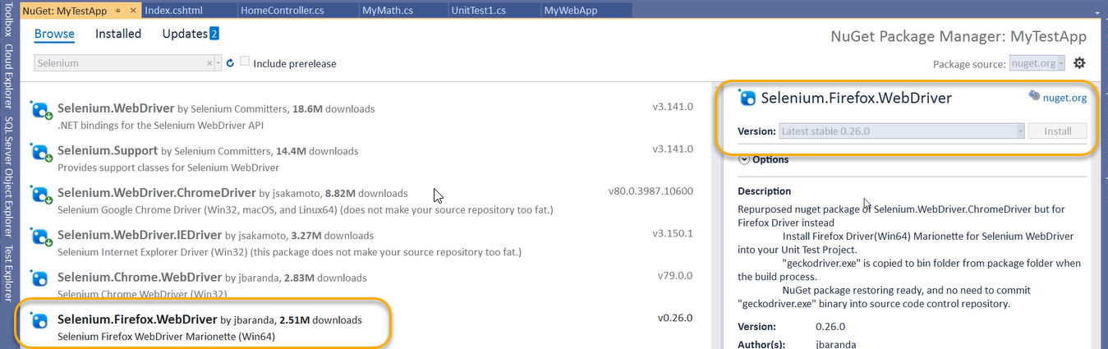

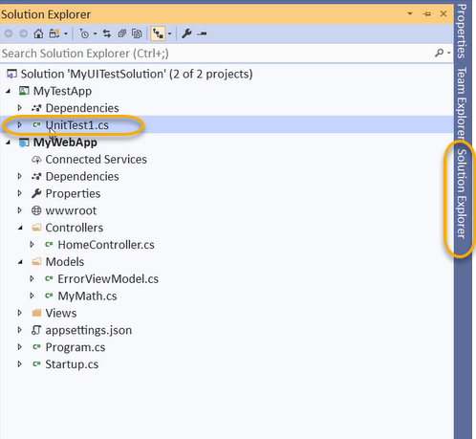

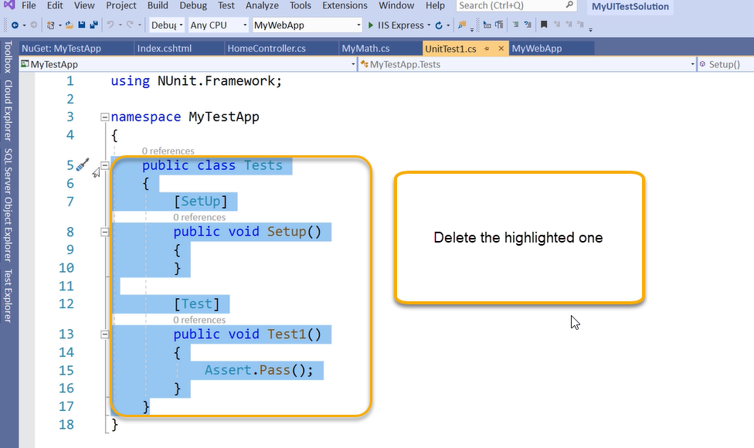

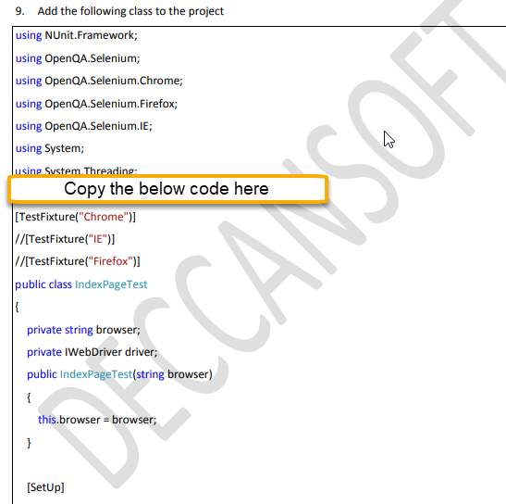

And paste it in the class

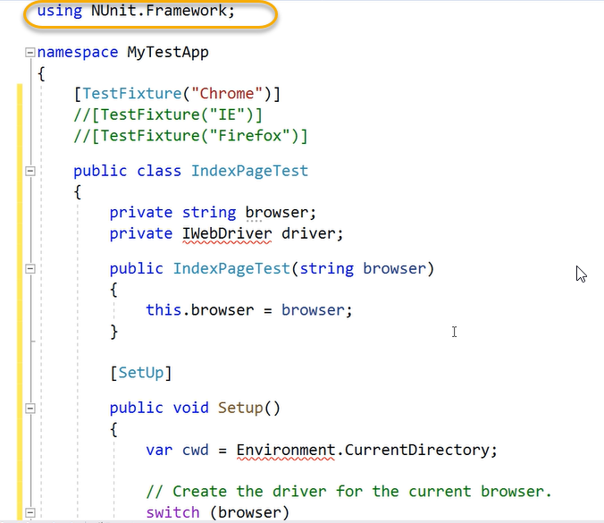

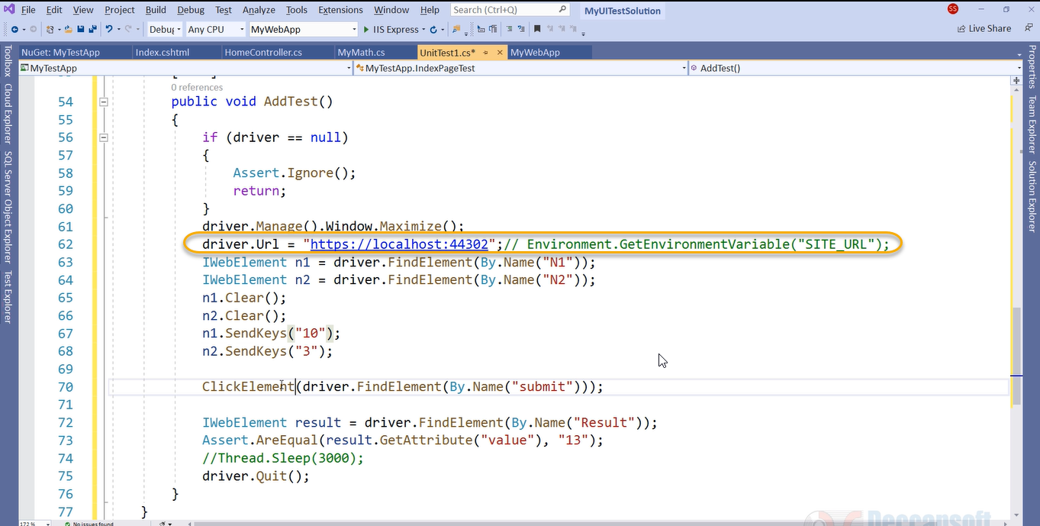

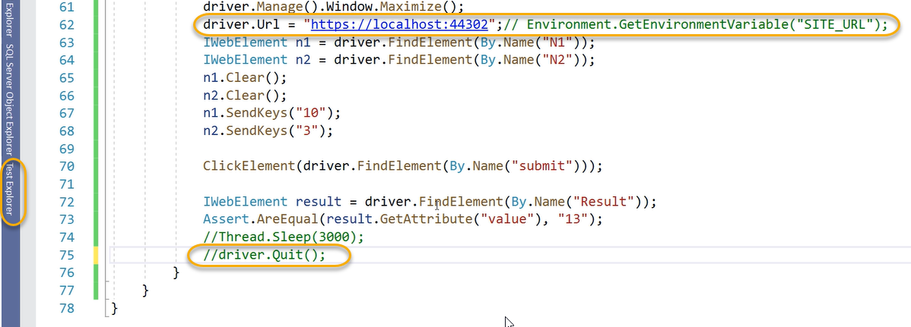

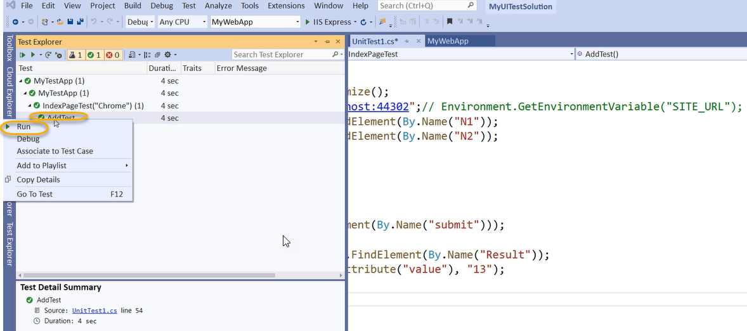

Or we can run from the below

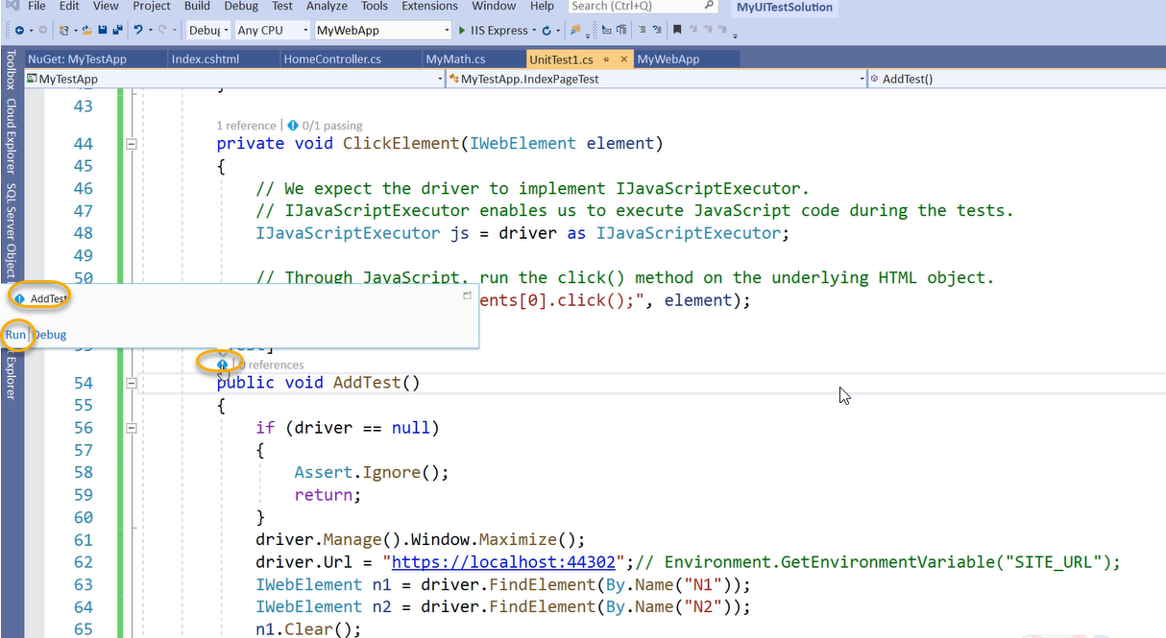

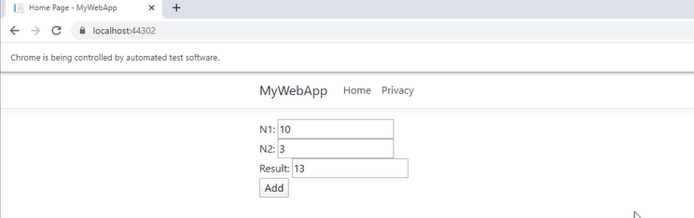

3-UI Tests in Release Pipeline

Move the application to repo

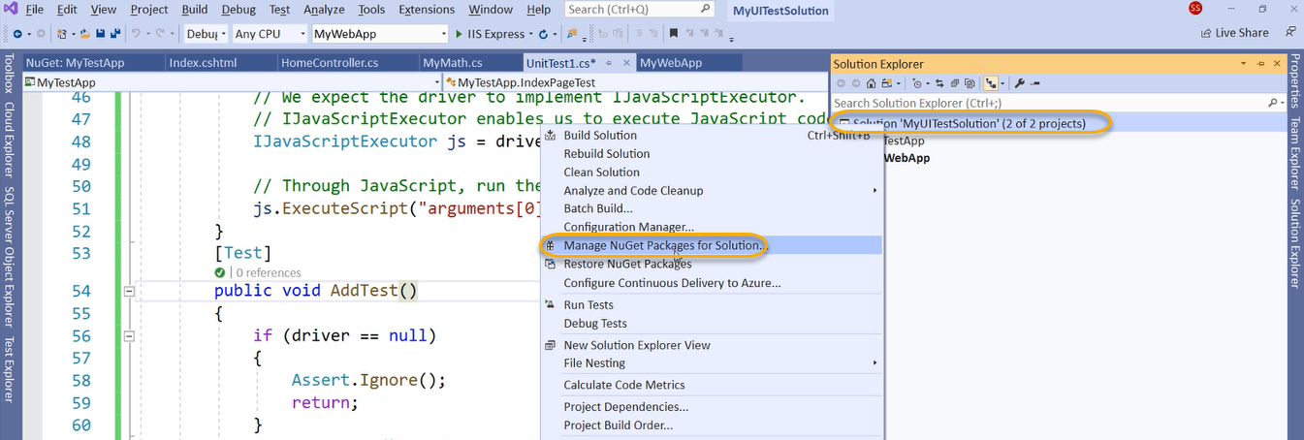

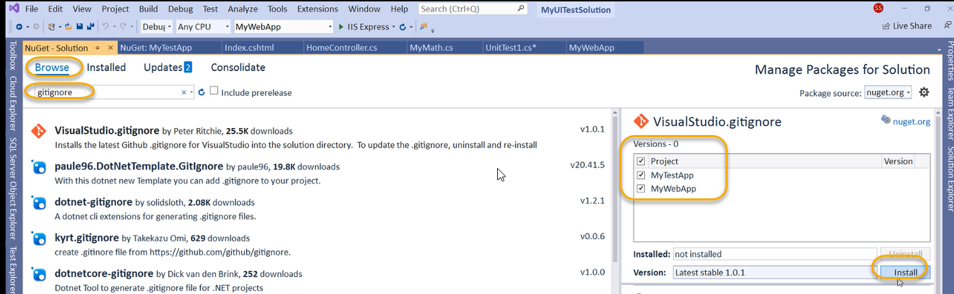

In DevOps we need to create a new project

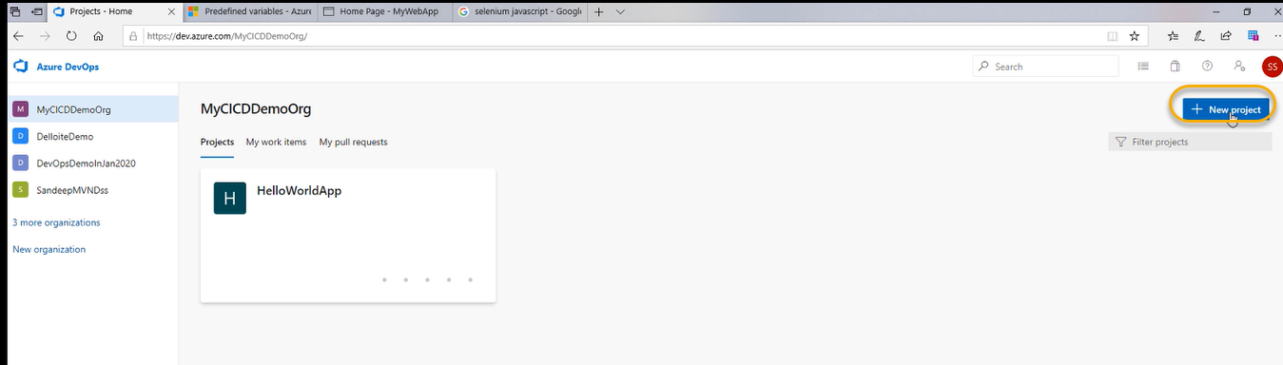

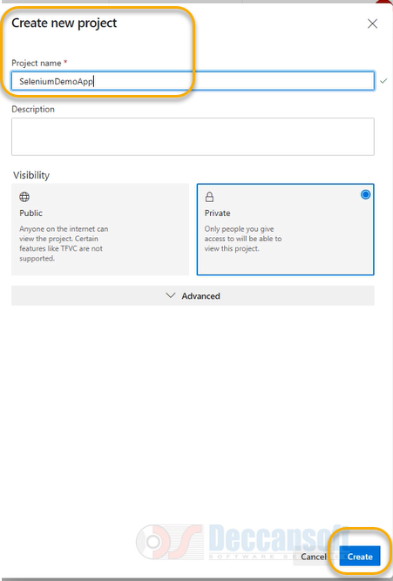

We need to add code to this source code

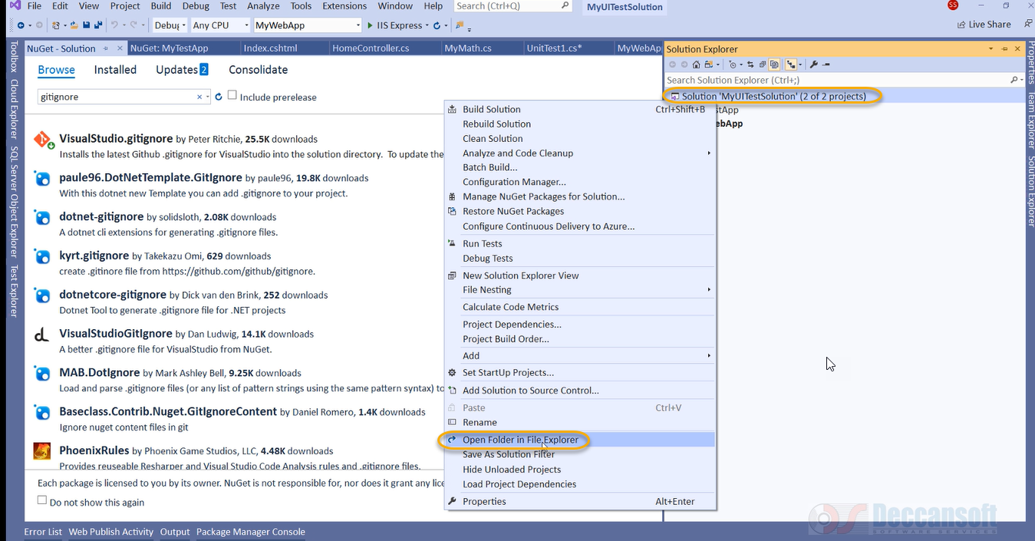

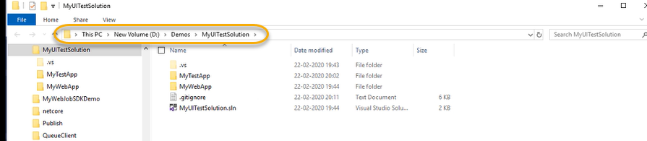

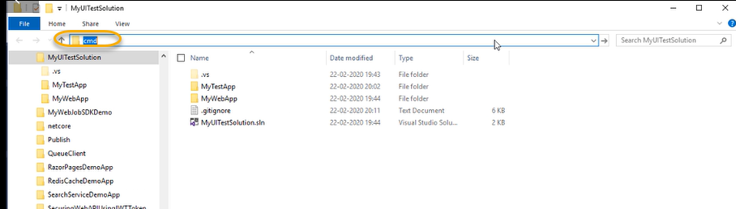

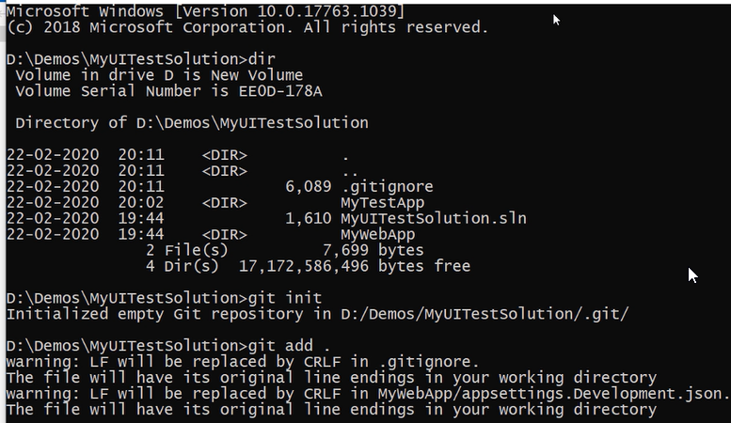

git commit -m “origin” master

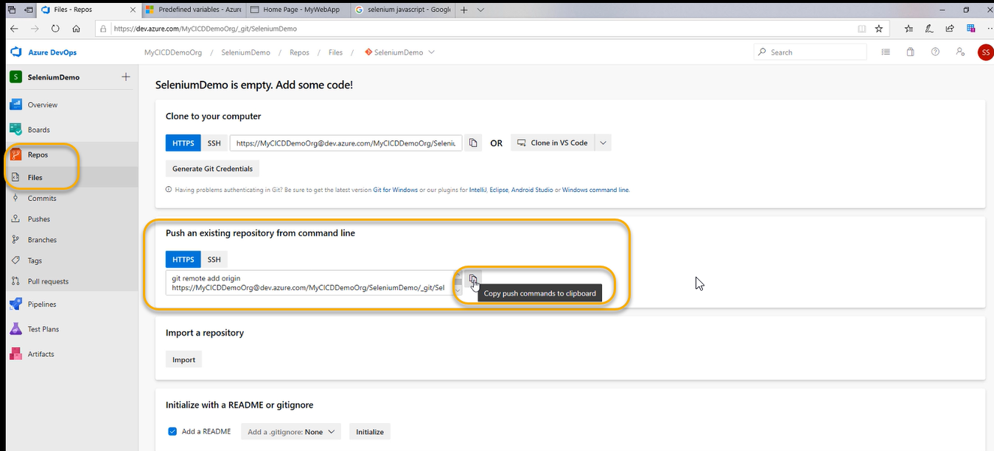

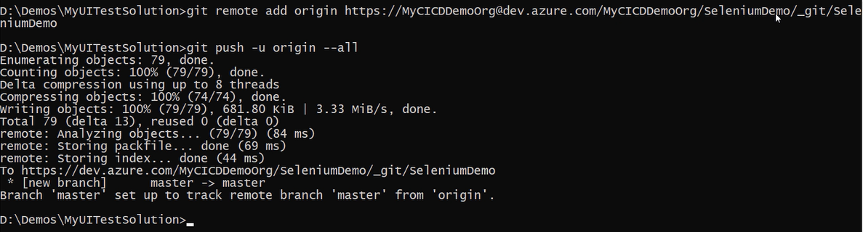

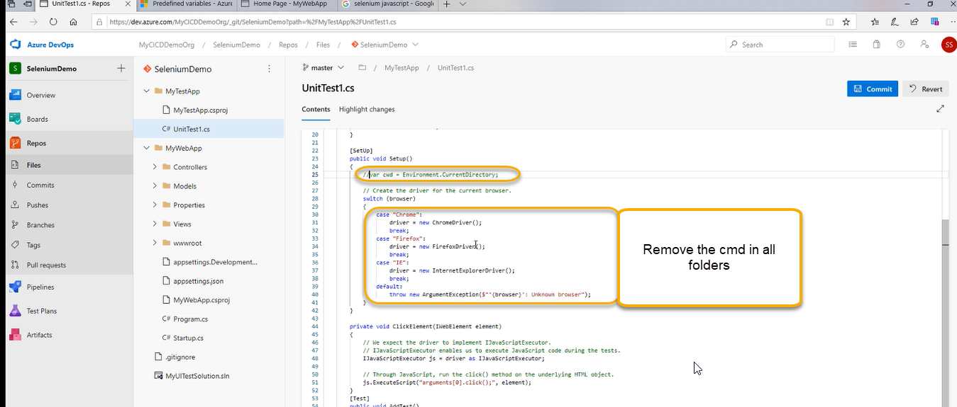

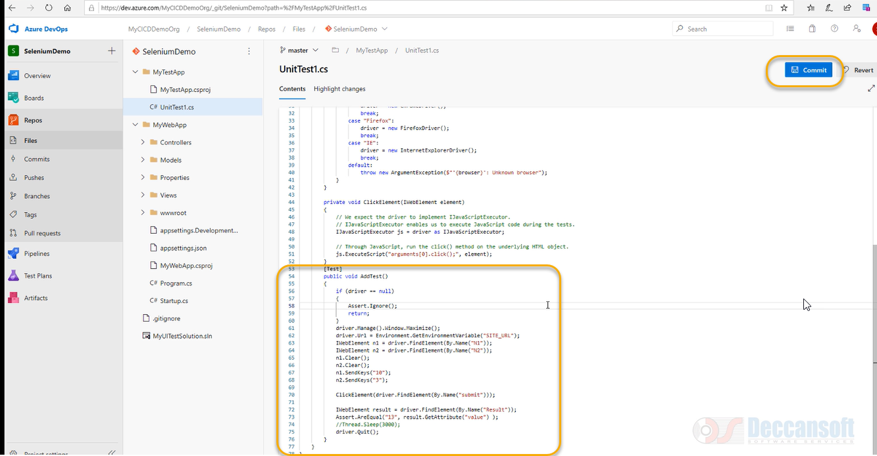

And again, click on commit

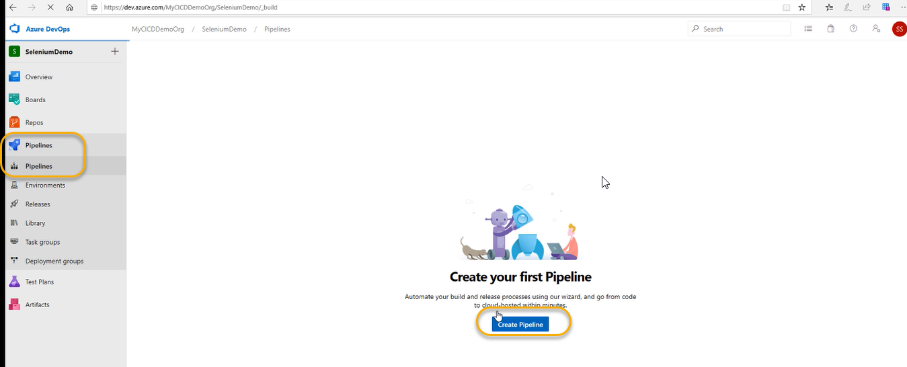

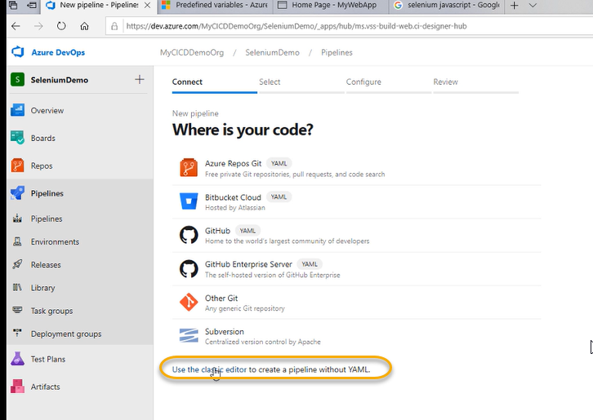

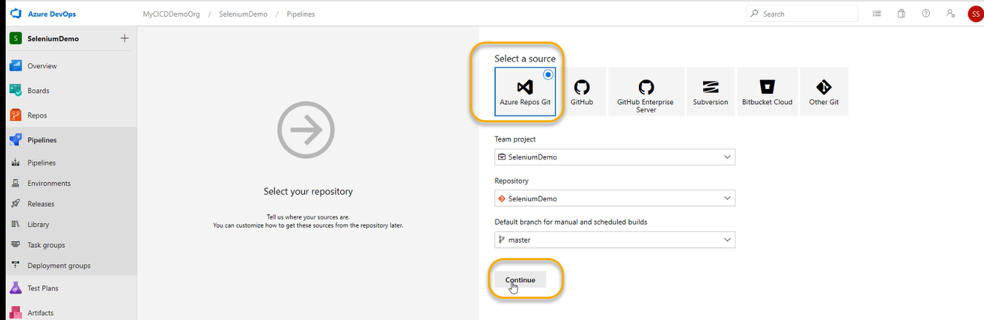

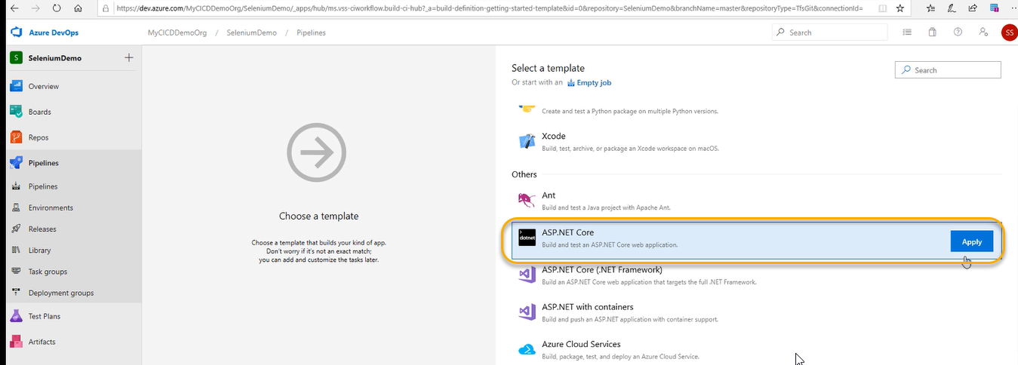

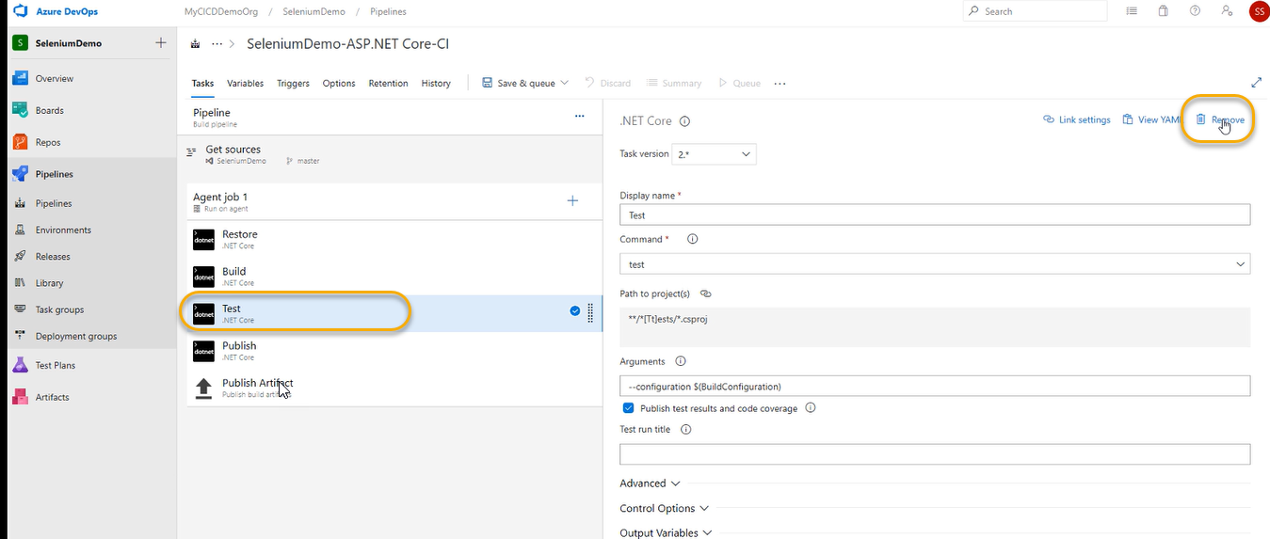

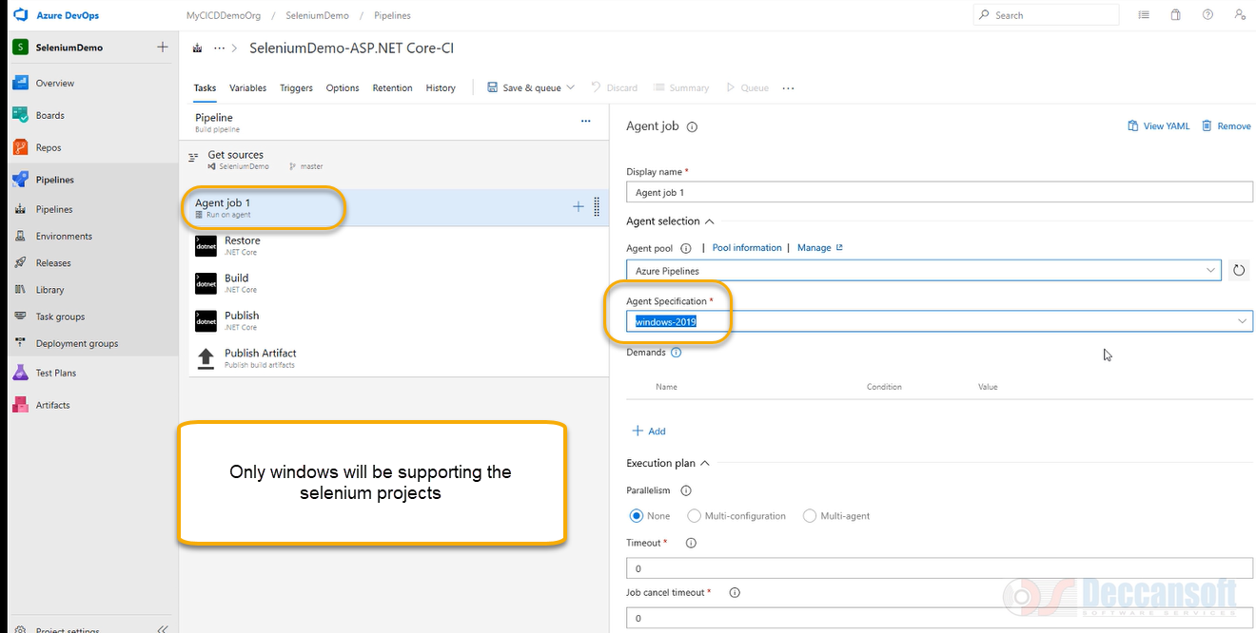

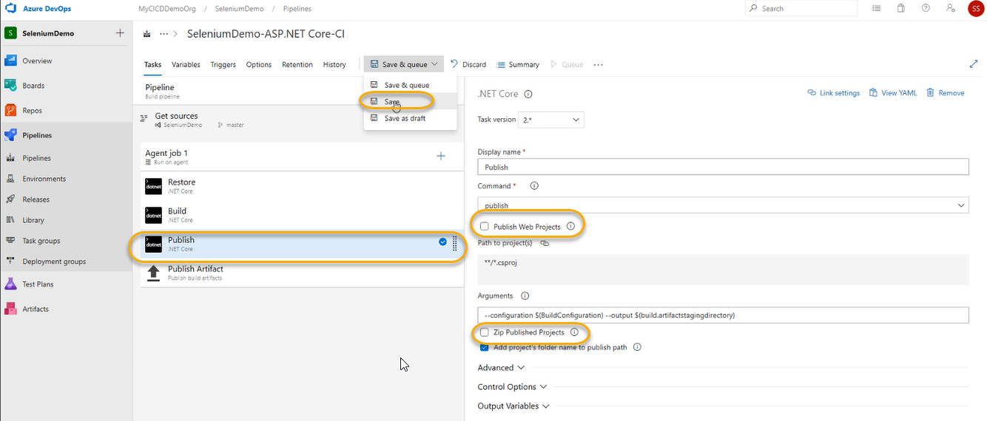

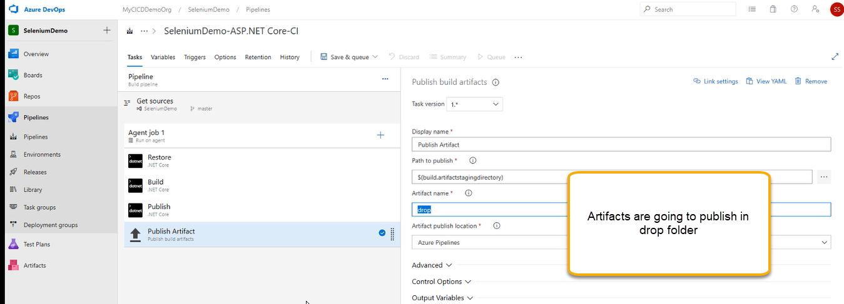

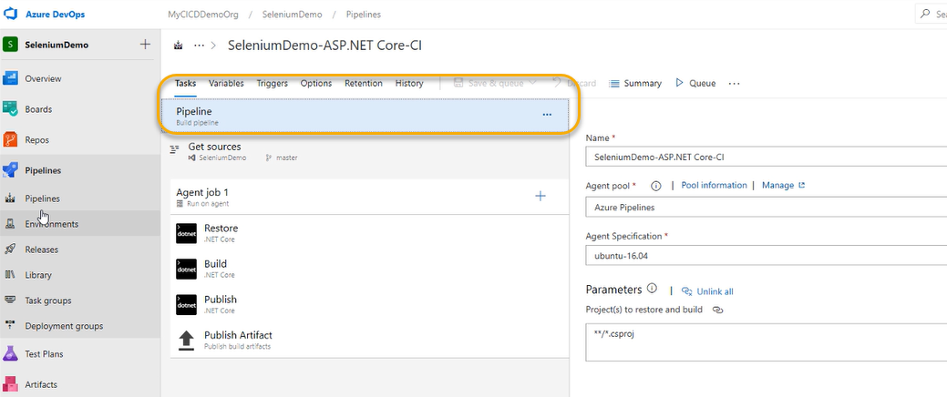

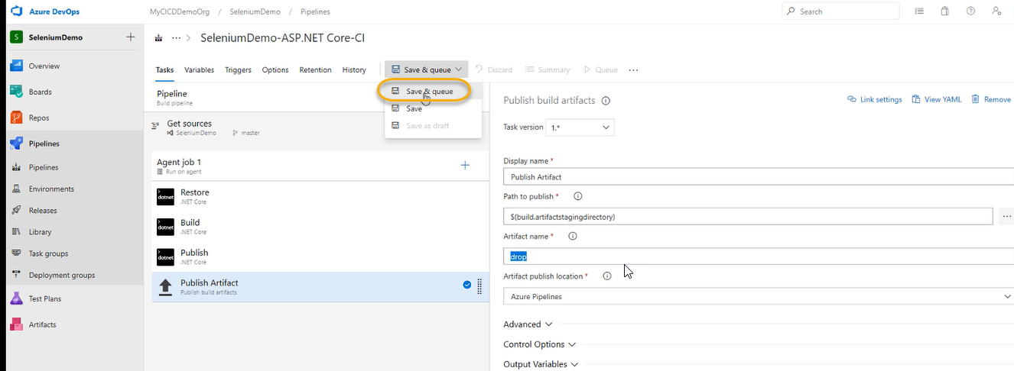

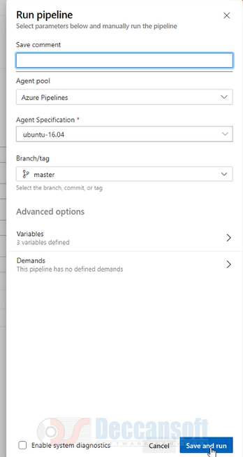

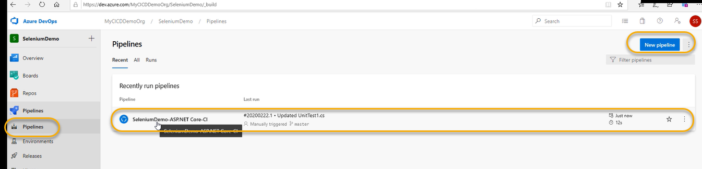

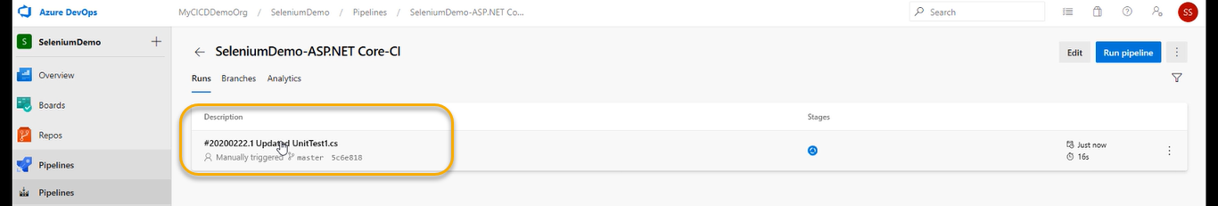

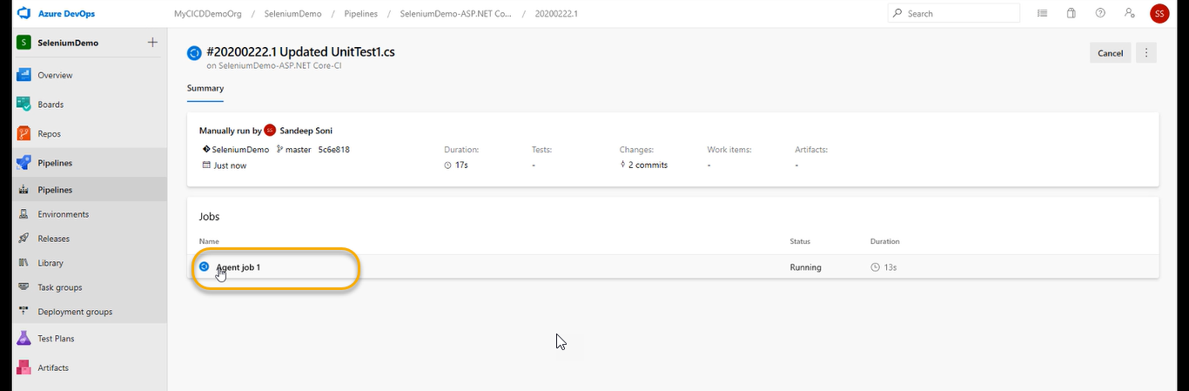

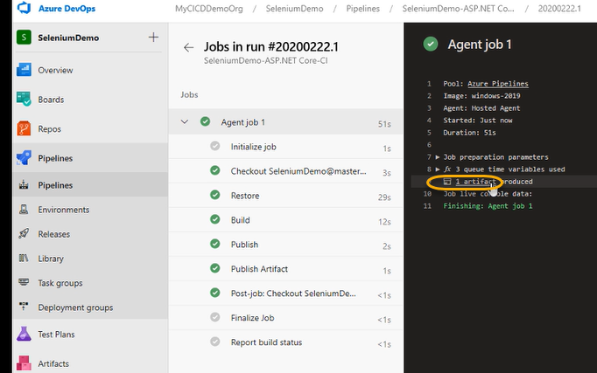

If the logs are NOT generated, then go back and come again

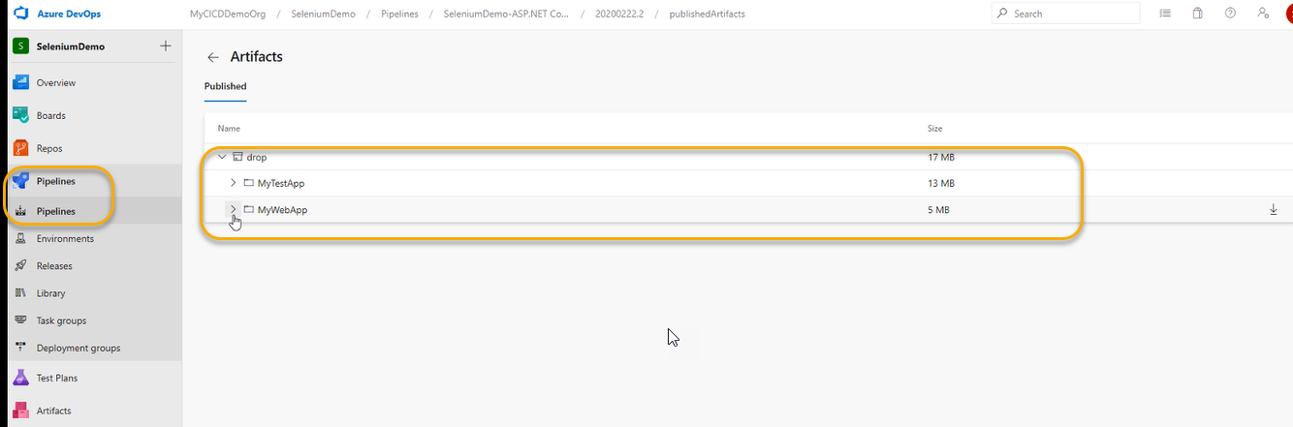

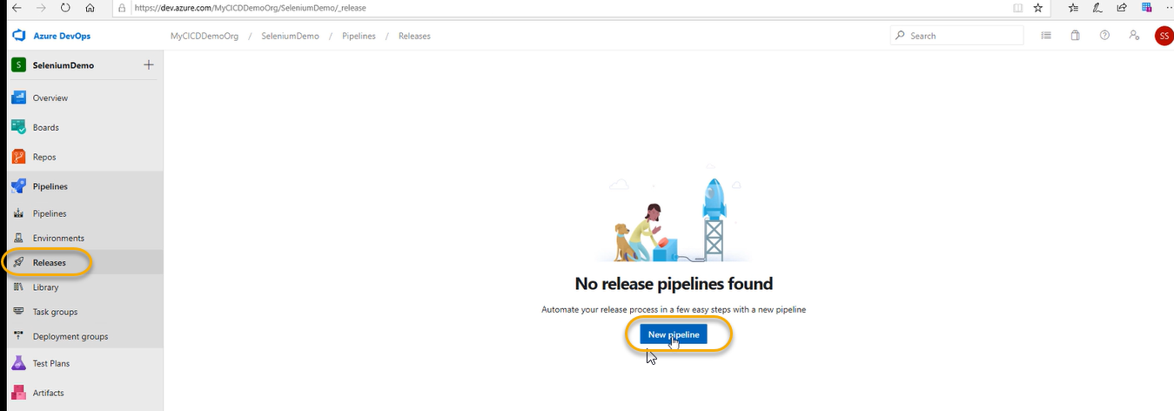

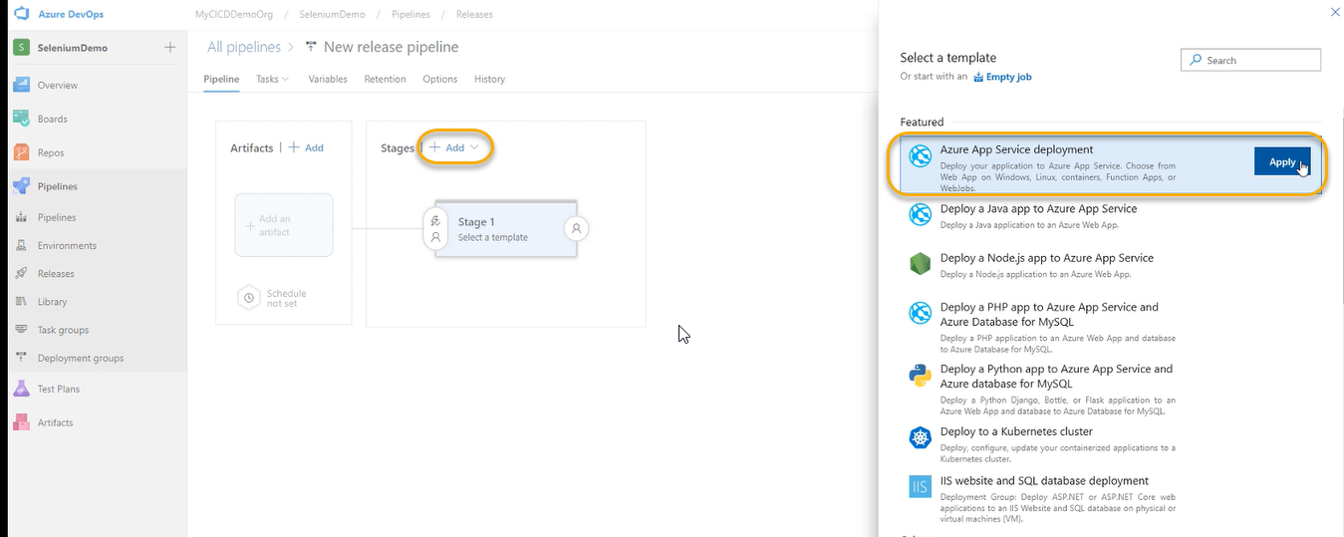

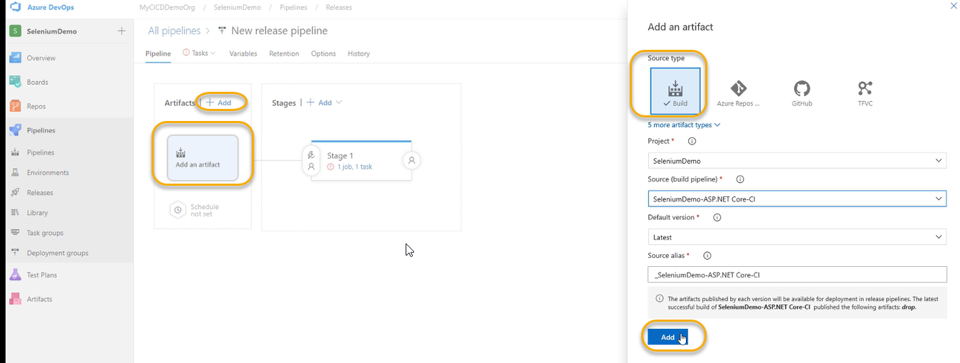

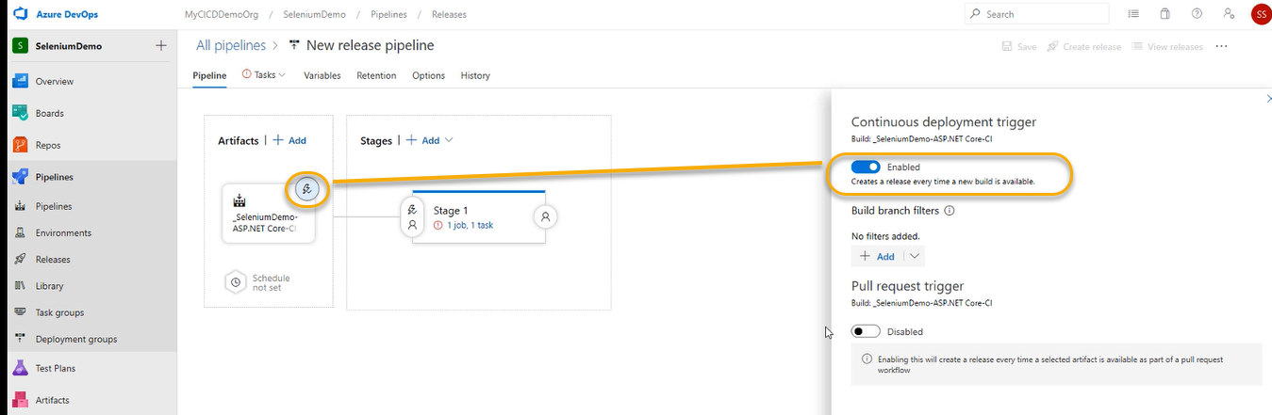

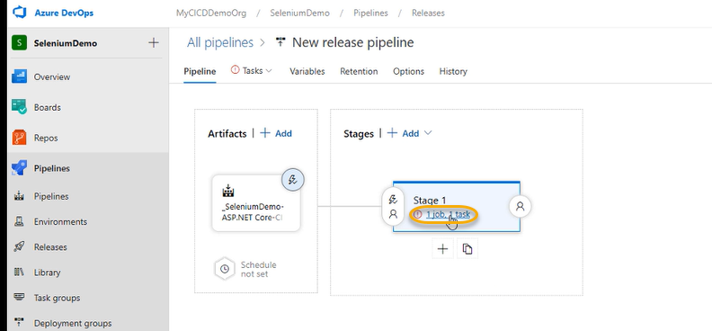

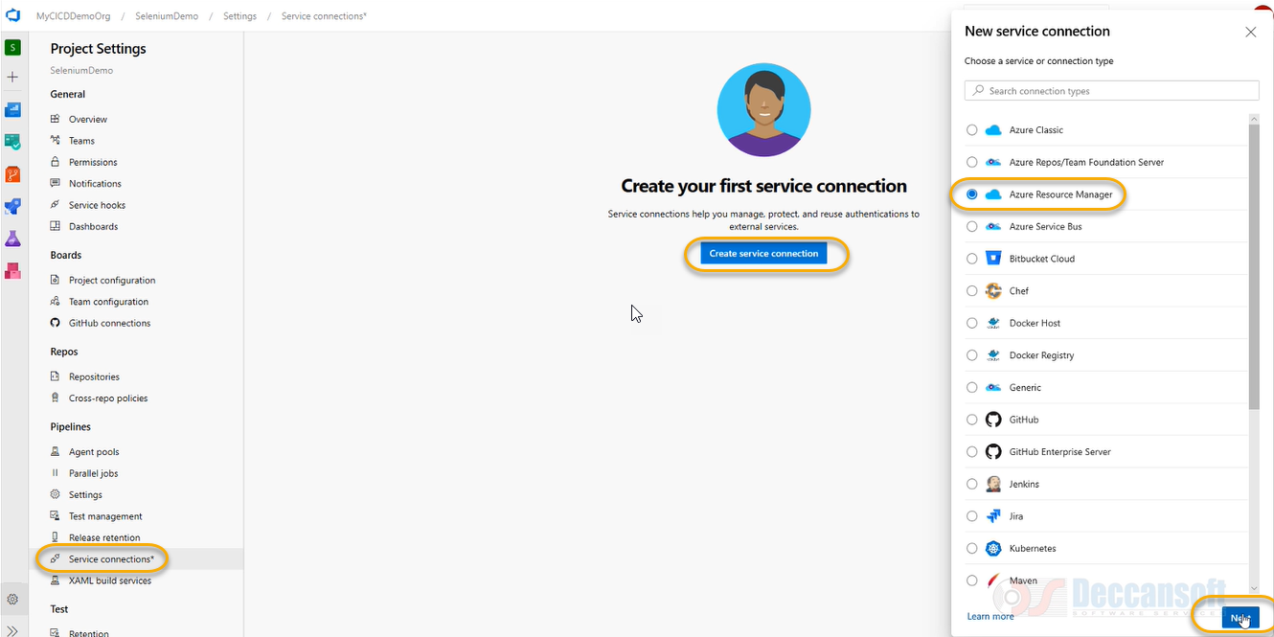

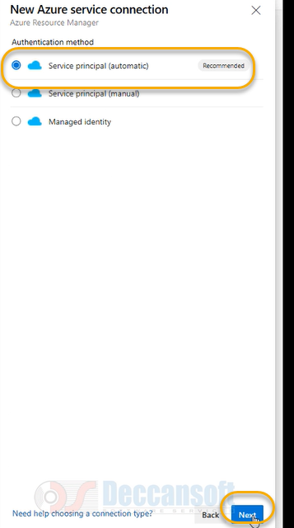

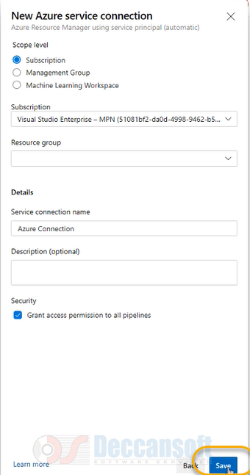

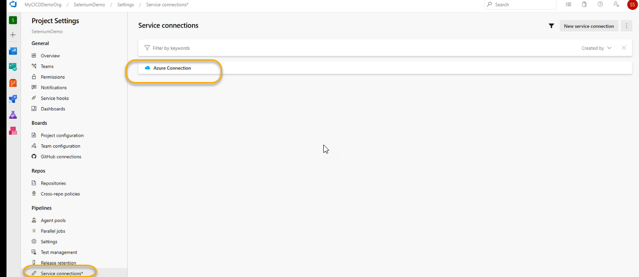



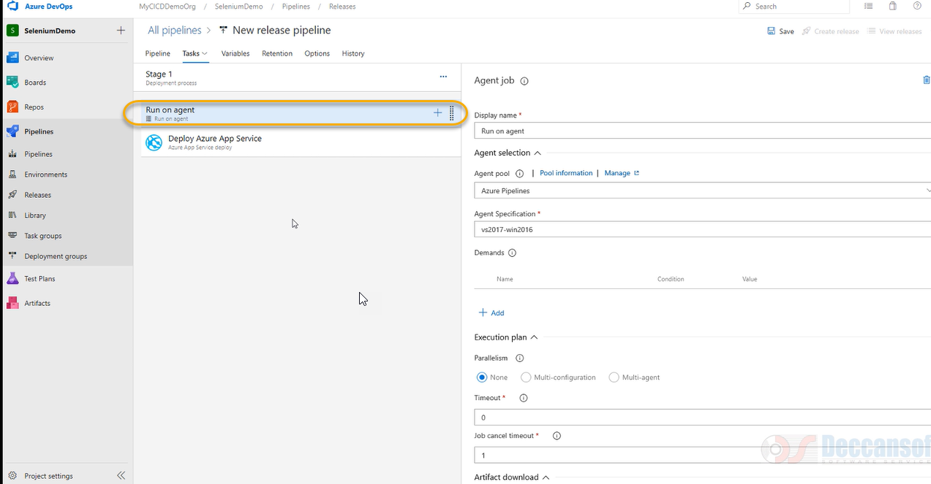

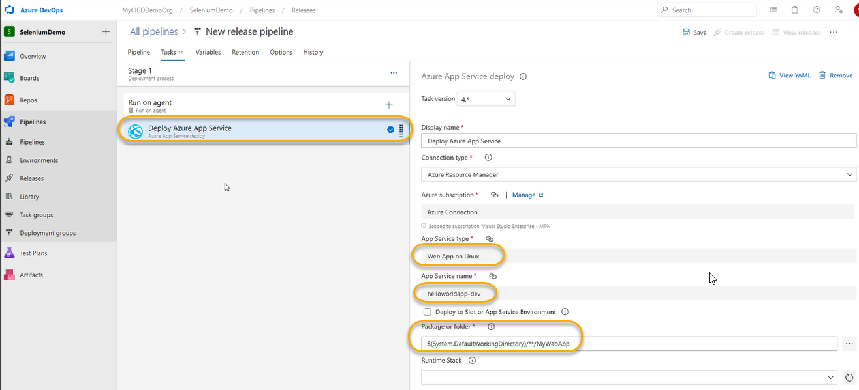

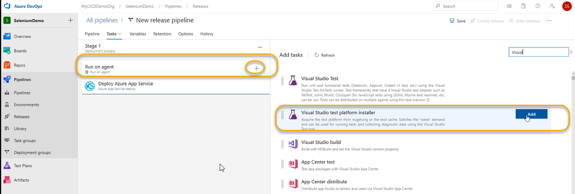

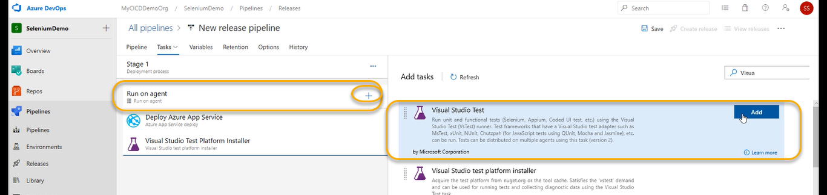

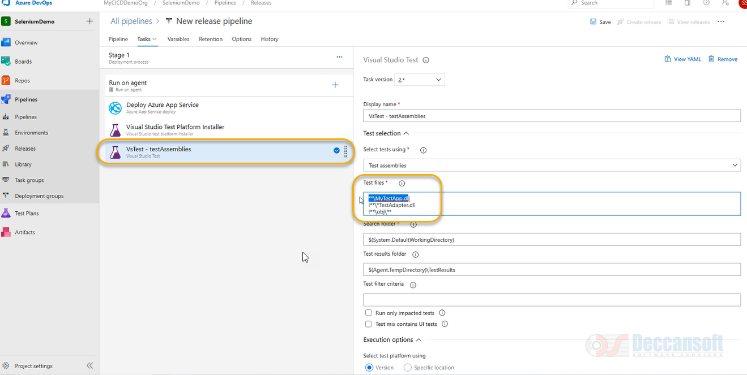

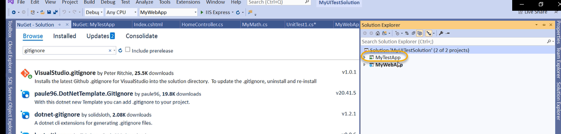

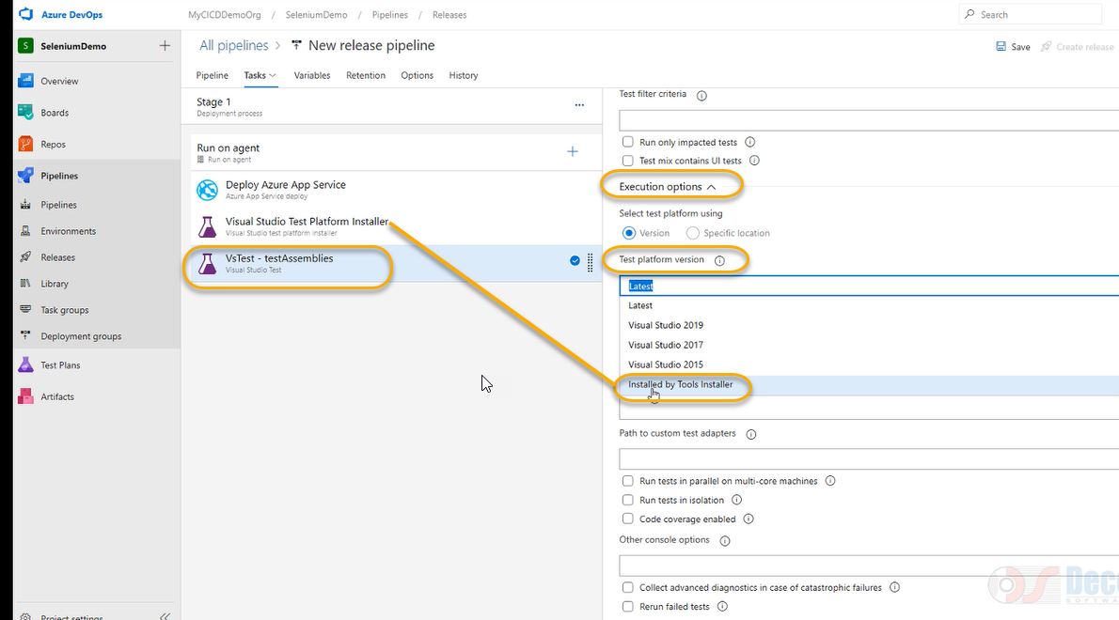

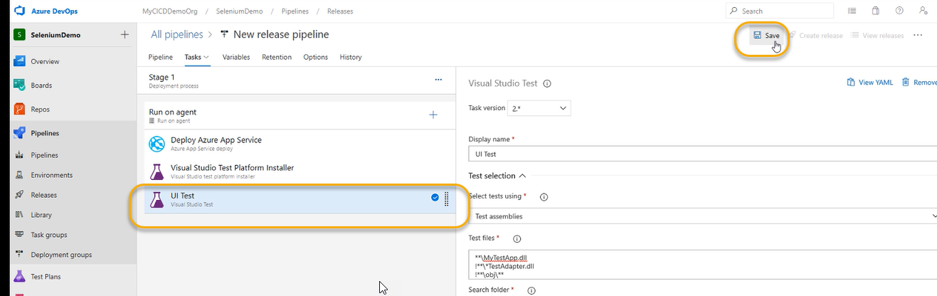

A pop will come and again click on save it

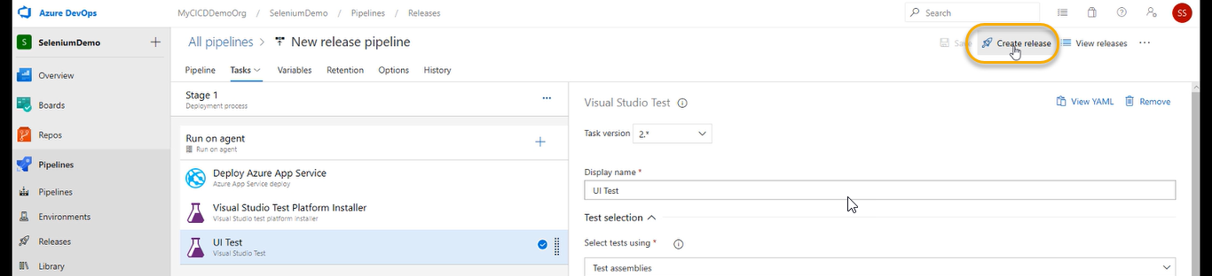

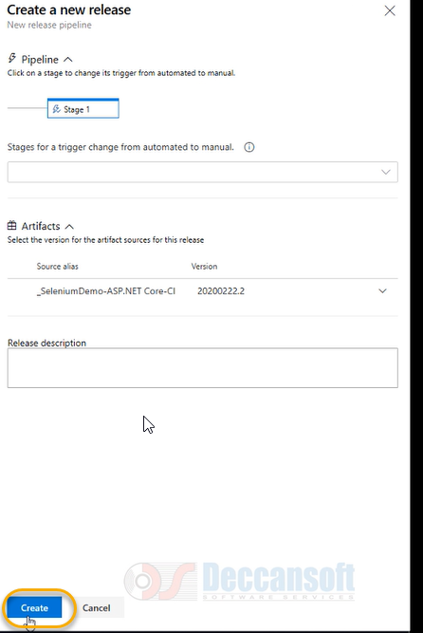

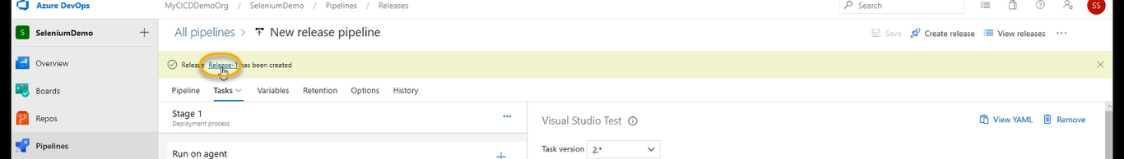

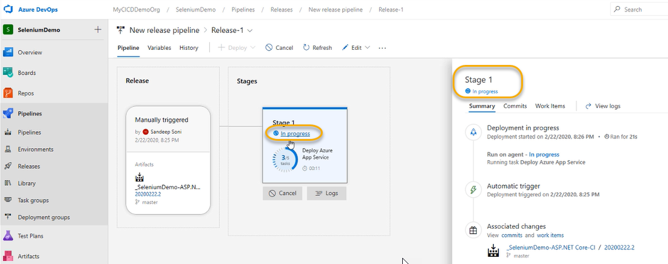

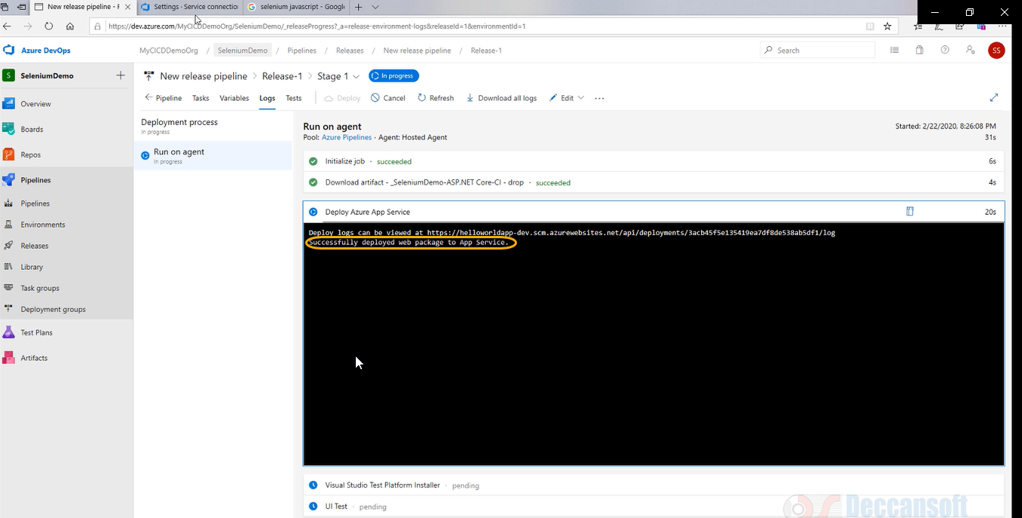

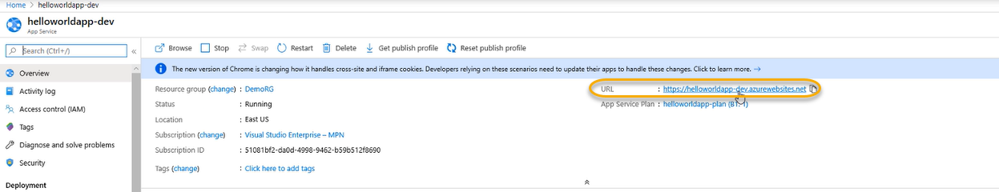

Copy url and paste it

Manually we are doing it

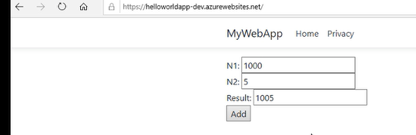

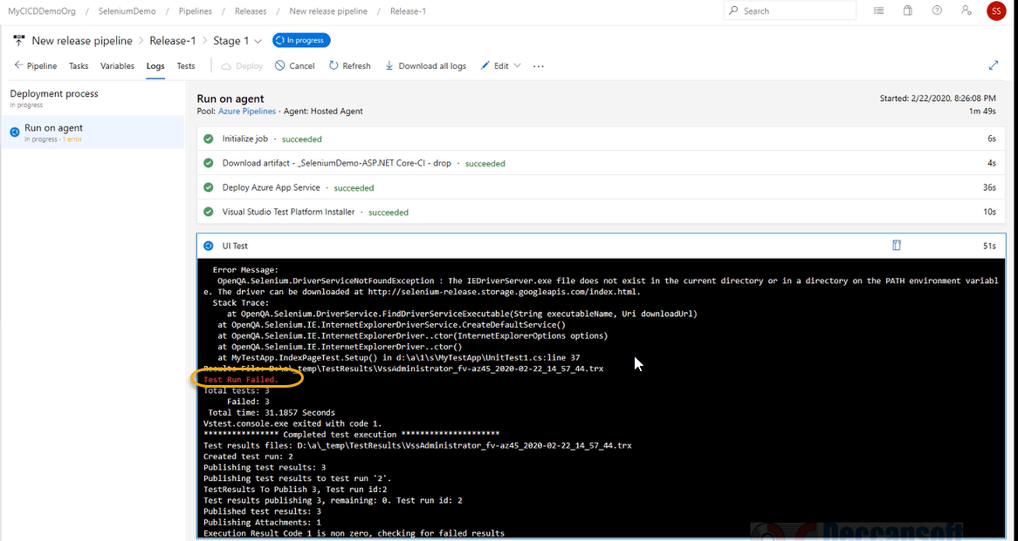

Actually, we did not give the variable we are supposed to set the environmental variable

So Release has failed

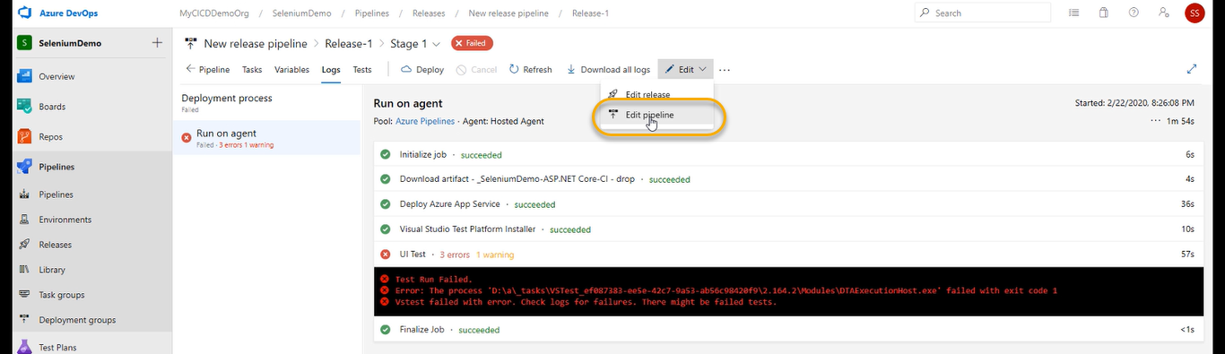

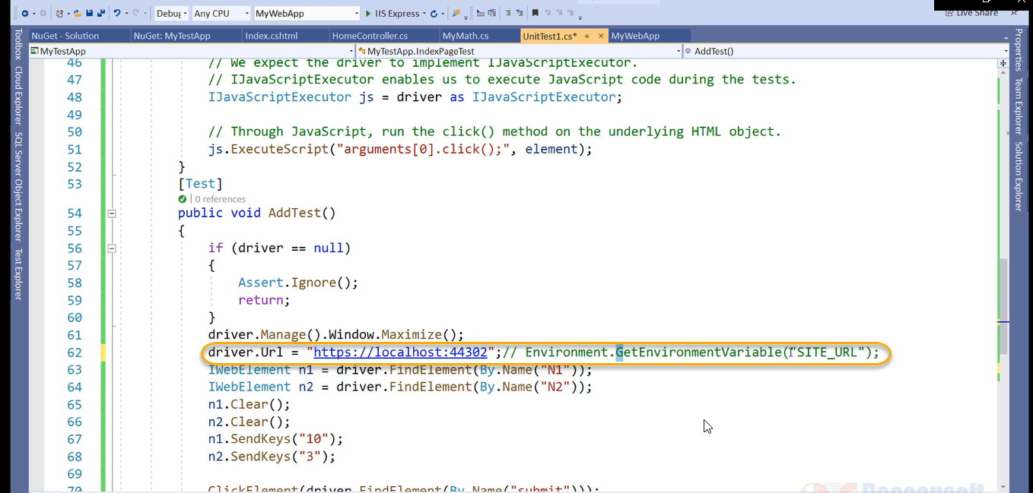

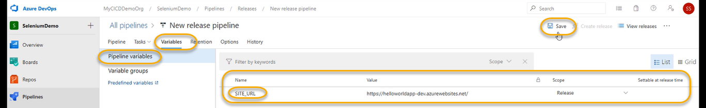

A pop will come and again save it

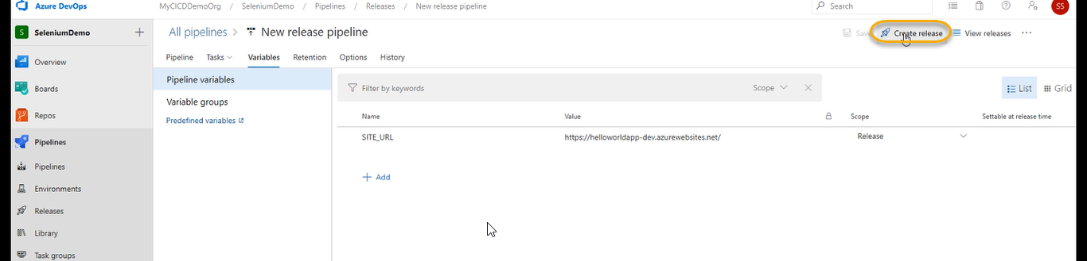

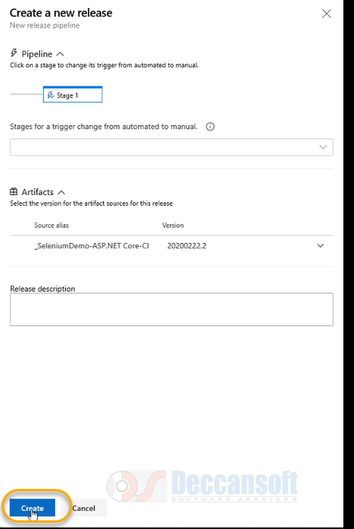

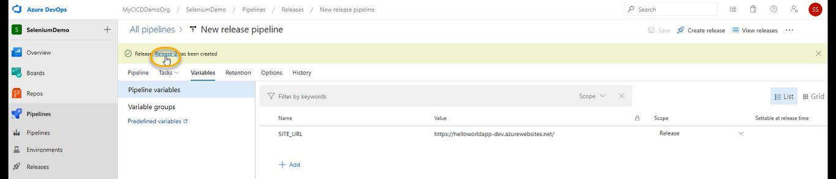

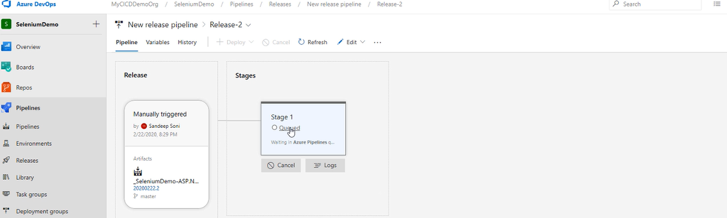

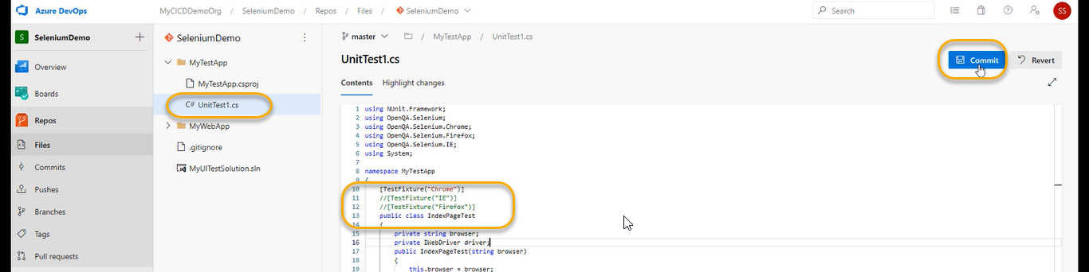

Right now, we cannot see the data because the agent is hosted is Microsoft. However, there is way to achieve it where we can the window will open and maximise it we need to perform the below steps

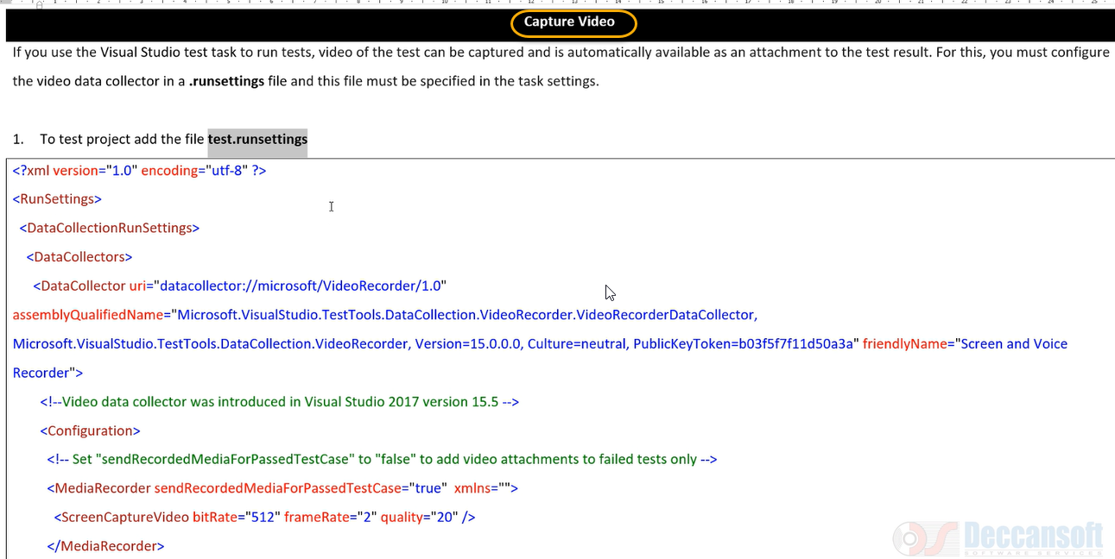

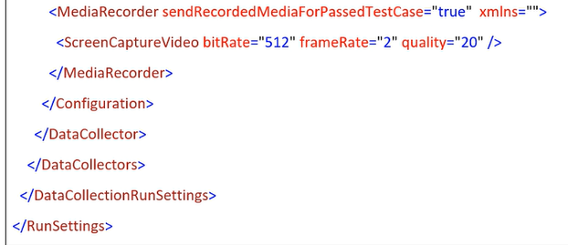

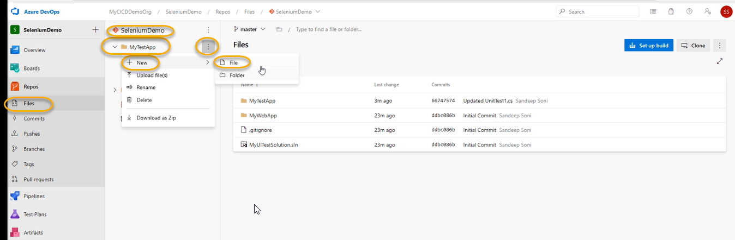

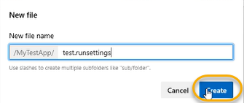

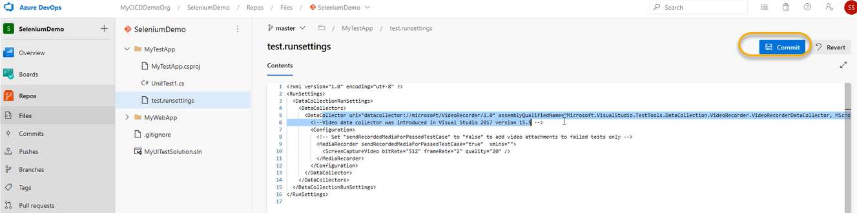

A pop will come again click on Commit

The path of test.runsettings file is what we will have to mention

In the CMD git pull origin master

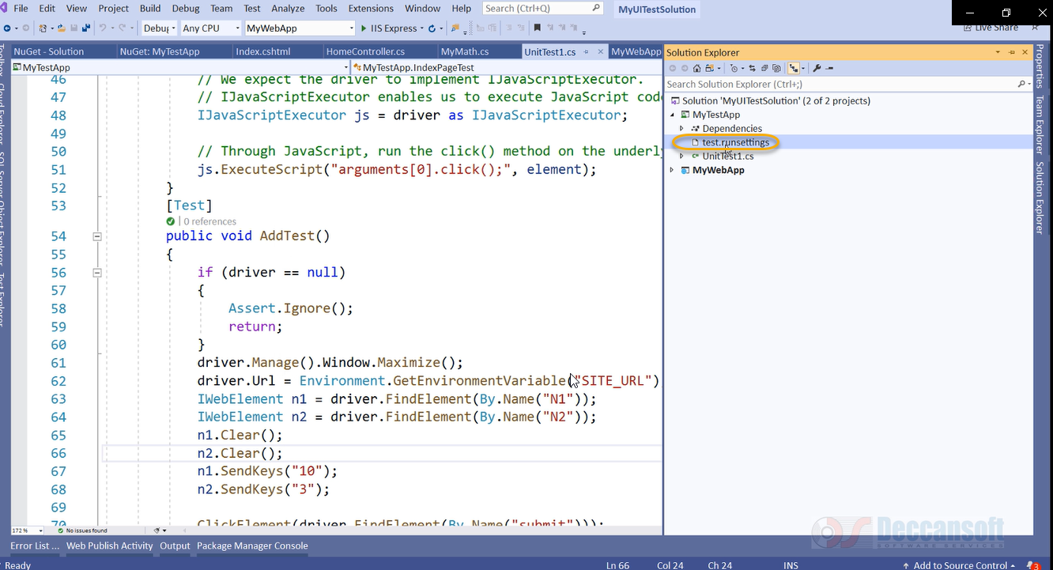

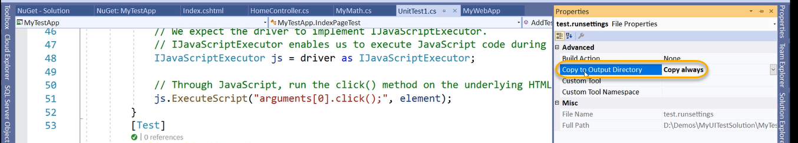

And save it

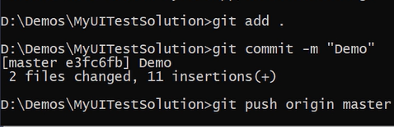

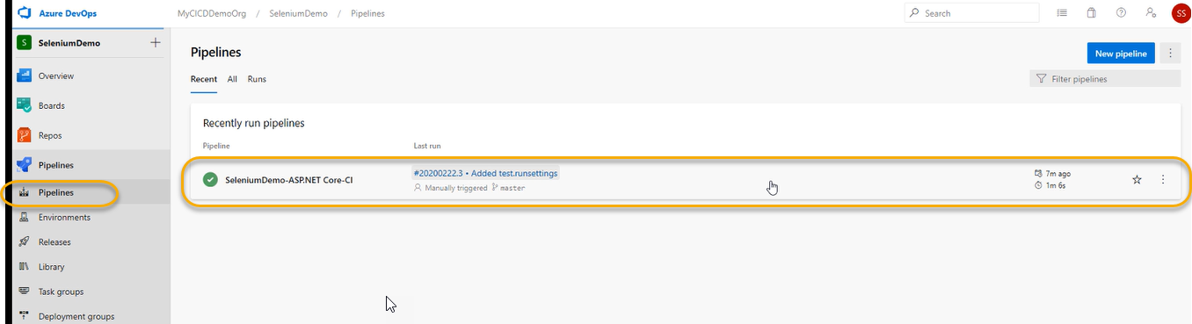

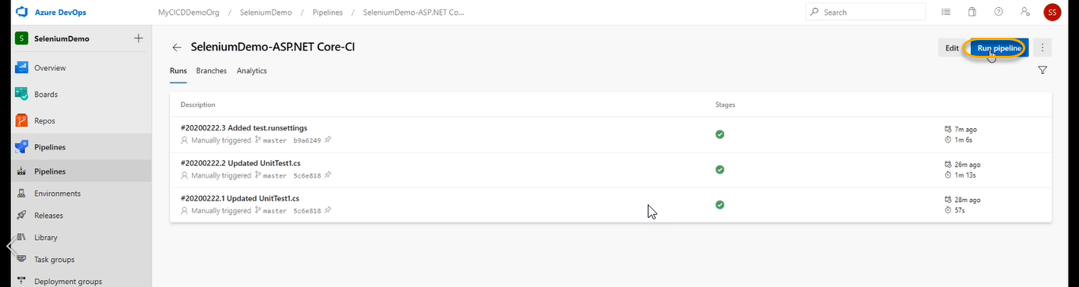

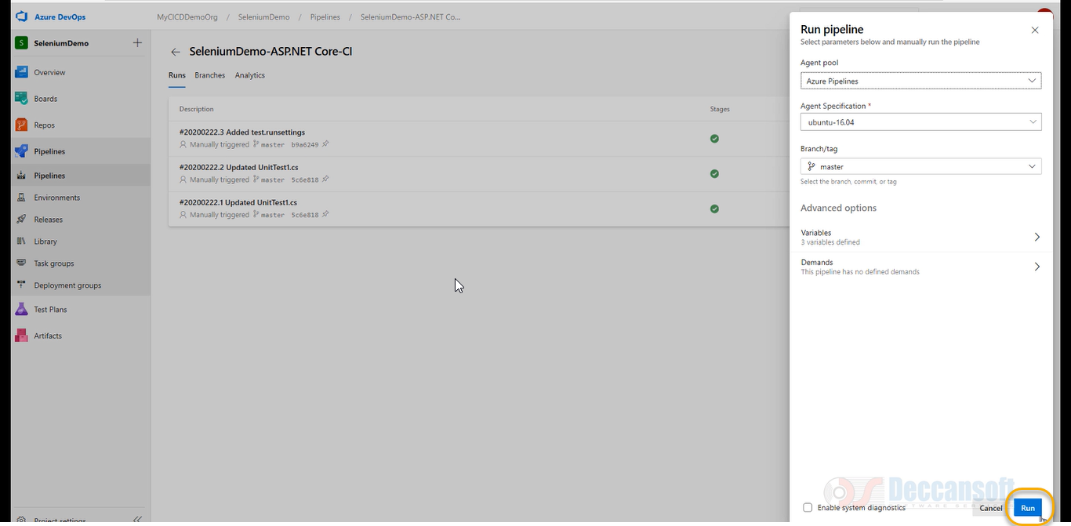

We need to assign the path to UI test in the release for that open any one of the failed path

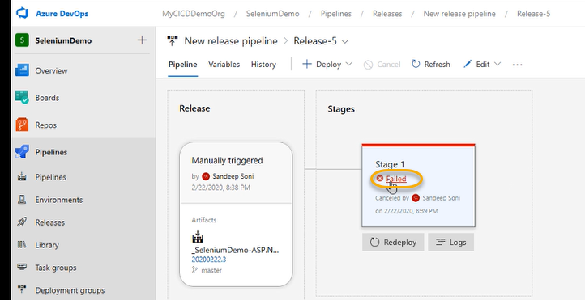

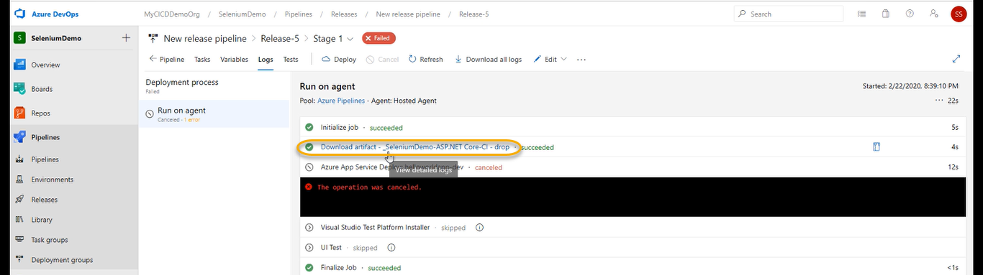

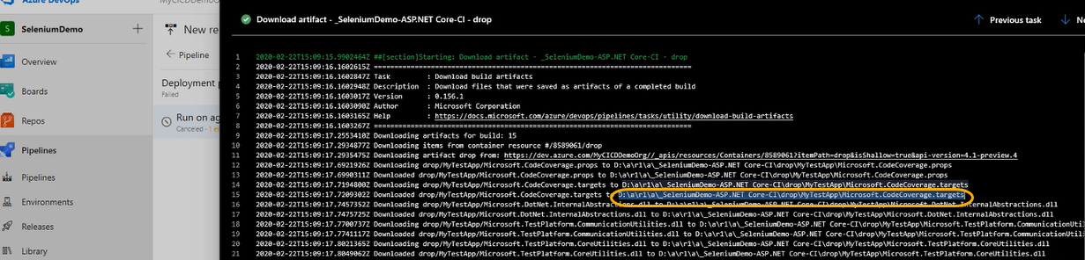

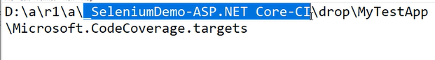

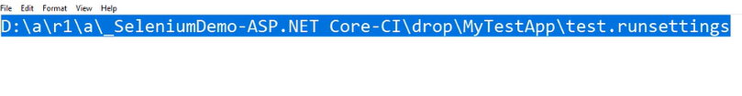

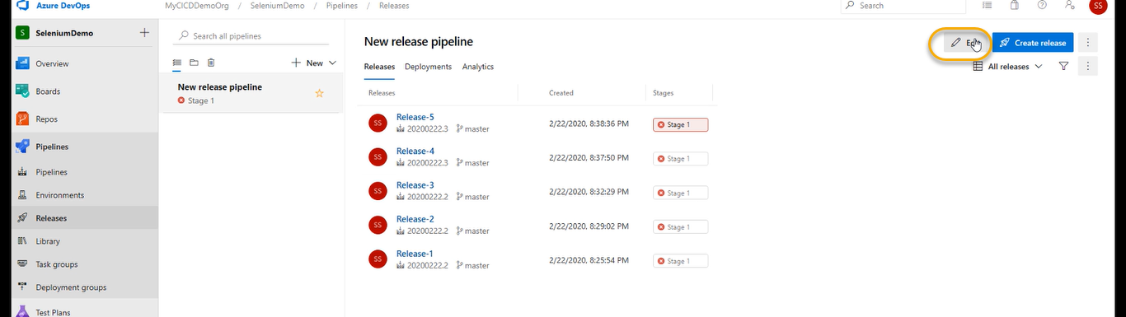

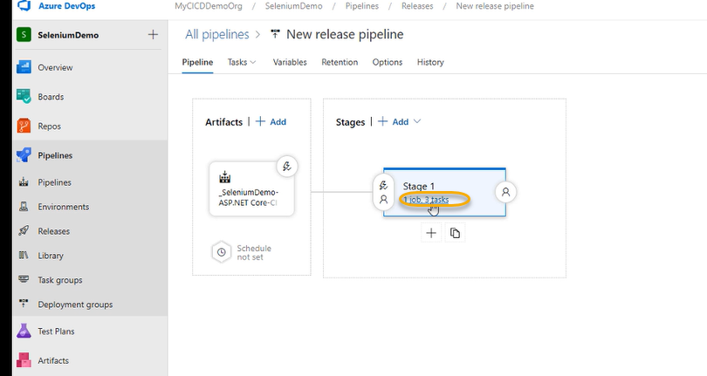

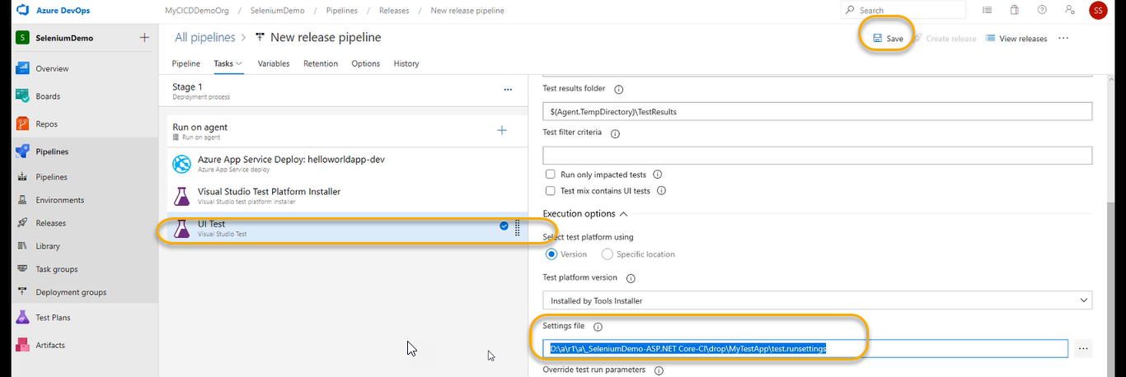

A pop will come again save it

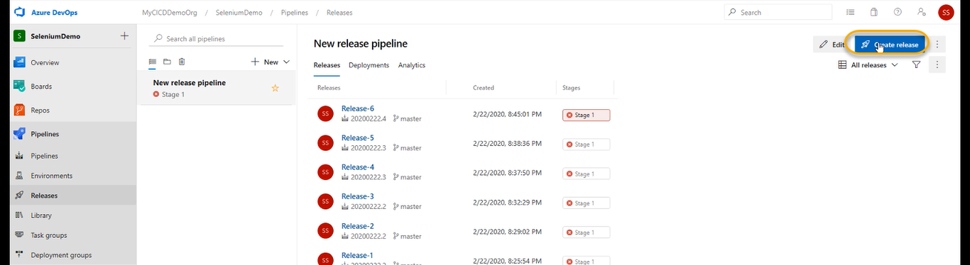

A pop will come and again click on create

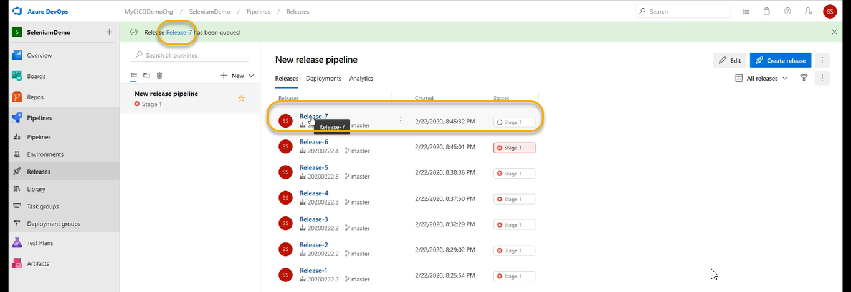



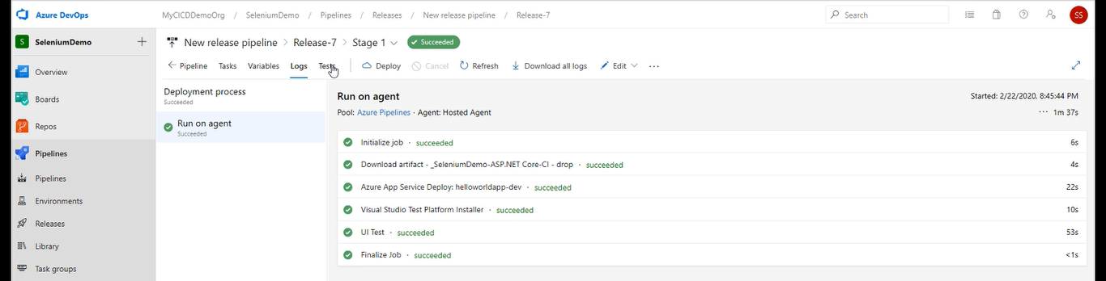

Lets go to the tests

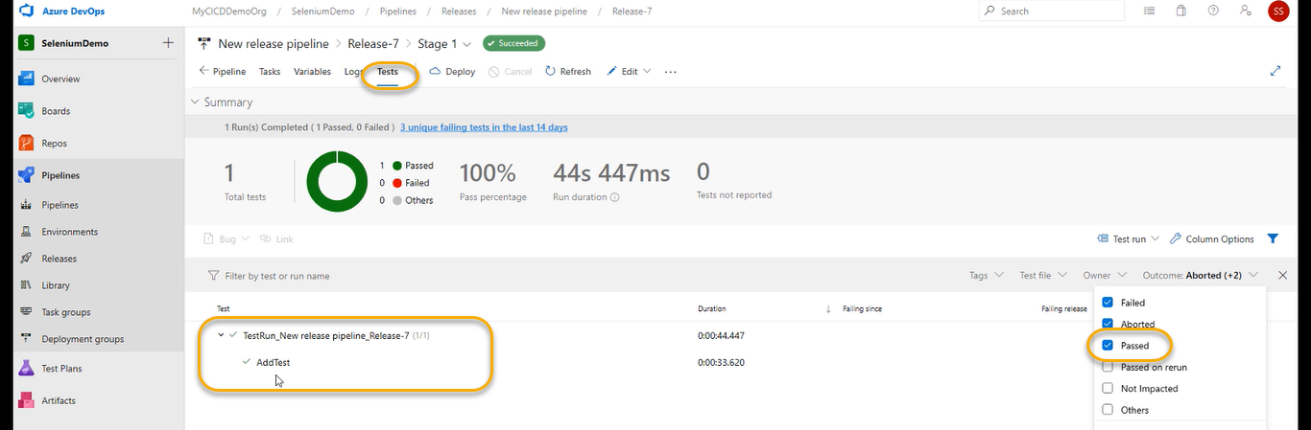

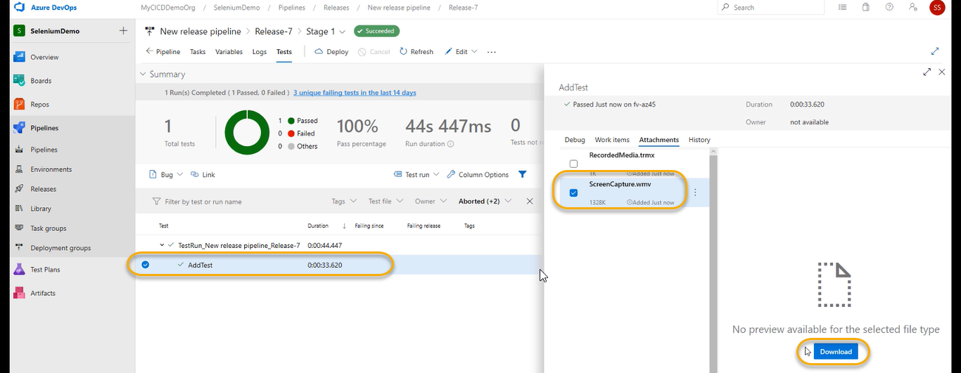

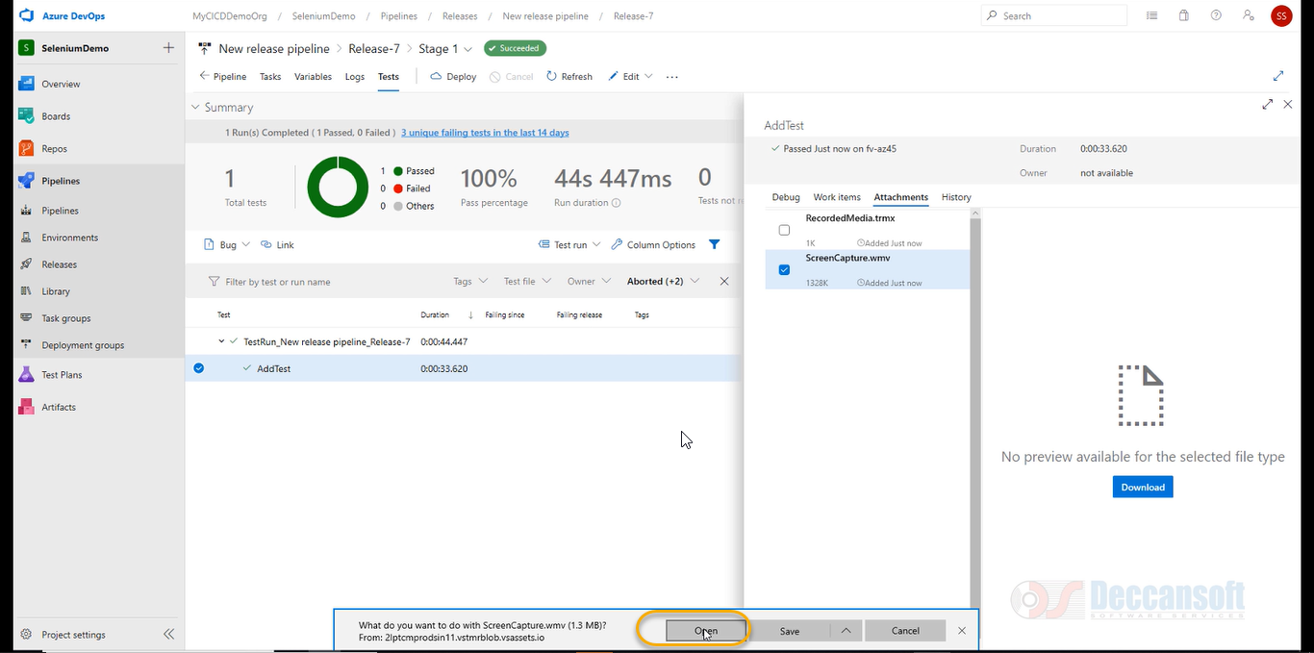

If you open the video it will play and we see the result

